Nearly 300 years of butchery tradition with a clear view ahead
Albmetzgerei Failenschmid relies on craft tradition, in-house training and technology from K+G Wetter

The main shop of Albmetzgerei Failenschmid in St. Johann-Gächingen on the Swabian Alb has been at the centre of the village for almost 300 years: 1740 is listed as the year it was founded. 250 years later, in 1990, today’s owner took over the family business from his father. Since then, Ludwig Failenschmid has combined centuries of tradition with a clear view of the years and decades ahead: he trains skilled butchers in his own workshop to preserve and pass on traditional craft knowledge. For decades, machines from K+G Wetter have also been an integral part of Albmetzgerei.

Craftsmanship meets high-tech

Anyone who listens to Ludwig Failenschmid can clearly sense the master butcher’s passion for traditional production and quality. The Failenschmid sausage kitchen regularly produces around 140 products, made by just under 20 butchers – all trained specialists. For bowl cutters and mixer grinders, the family has relied exclusively on technology from K+G Wetter for many years. “My father bought the first machines back then,” recalls Ludwig Failenschmid. “Another manufacturer? That idea did not exist then, and it still does not.”

Currently in operation: a VCM 120 vacuum bowl cutter with cooking function. “A vacuum bowl cutter of this size is quite exceptional in an artisan butcher’s business,” says Ralf Klein, K+G Wetter regional sales manager, who has been working with Albmetzgerei for many years. The vacuum bowl cutter supports the butcher shop’s quality standards and also brings advantages in processing time: “Take veal liver sausage as an example of a cooked sausage: over the entire process, we save around one third of the time, based on our experience,” says Ludwig Failenschmid.

The MWW 130 mixer angle grinder from K+G Wetter, purchased at SÜFFA 2024, performs a wide range of tasks at Failenschmid. In addition to grinding meat for minced meat or mixing and processing raw sausage meat, the company also uses the grinder to remove cartilage and sinew from meat before further processing in the bowl cutter. Thanks to the pneumatic sorting device and K+G Wetter’s ClearCut knife system, only the one to two per cent of hard components are carefully removed. This prevents meat waste and keeps the connective tissue in the sausage meat – a decisive factor for a good “bite” in scalded sausage production.

Unique: Alb buffalo specialities from Albmetzgerei

Alb buffalo products are a special offering from Albmetzgerei Failenschmid. “The meat is completely different from normal beef,” says Ludwig Failenschmid. “It is much closer to game, with a very dark colour and long meat fibres.” Another special feature: Alb buffalo meat has no intramuscular fat at all. It is lean, rich in protein and therefore well suited to modern nutrition – but challenging to process. Once again, K+G Wetter bowl cutter technology provides support: the raw sausage knife head with sickle knives ensures a clear cutting pattern. The removable baffle plate increases the cutting space and prevents protein extraction and a greasy film around the particles, while the vacuum function draws air pockets out of the sausage meat. The result: raw sausage with an ideal structure that dries and matures optimally and has a long shelf life.

The future needs traditional knowledge and new talent

To ensure that Failenschmid’s butchery tradition continues to thrive through its 300th anniversary and beyond, Ludwig Failenschmid invested in his own training workshop two years ago. “We currently have six lads learning with us, all from the region and from farming backgrounds. They are great and really on the ball!” says Ludwig Failenschmid enthusiastically about the next generation of skilled workers.

For this, Ludwig Failenschmid brought master butcher and long-time vocational school teacher Edgar Kuhn out of retirement especially to act as trainer. “That was an incredible stroke of luck!” With him, the aspiring butchers learn the fundamentals of the craft in practice and theory – and not least the tricks, techniques, passion and enthusiasm for the butcher’s trade. “It is important to me that the apprentices learn and understand traditional production from the ground up, with as little technology as possible,” says Edgar Kuhn. The technology in the training workshop is therefore straightforward – but here, too, the SM 33 bowl cutter and EW 98 electric grinder from K+G Wetter are used.

What the Failenschmid apprentices produce in the workshop with Edgar Kuhn is sold in the always well-frequented shop in the centre of Gächingen and promoted as a trainee product. “It is really popular; customers actively ask for it. That makes our lads very proud,” say the trainer and operations manager. One success that has resulted from this: Failenschmid receives enquiries about apprenticeships instead of having to spend time looking for trainees.

Albmetzgerei Failenschmid H-Albzeit

Photos (K+G Wetter)
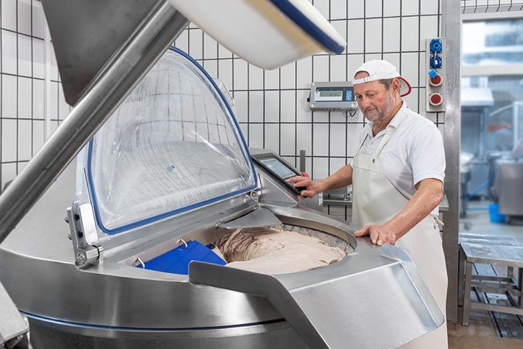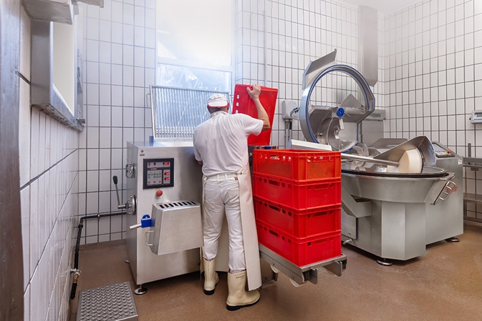
Albmetzgerei Failenschmid relies on bowl cutter and grinder technology from K+G Wetter: the VCM 120 vacuum cooking bowl cutter (left) and the MWW 130 mixer angle grinder with the Easy Lift lifting system.

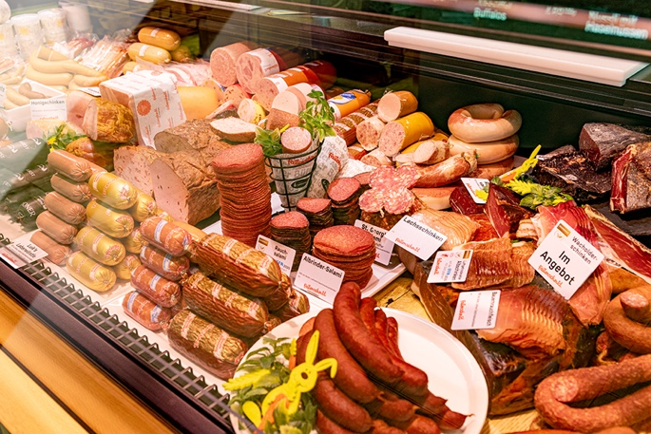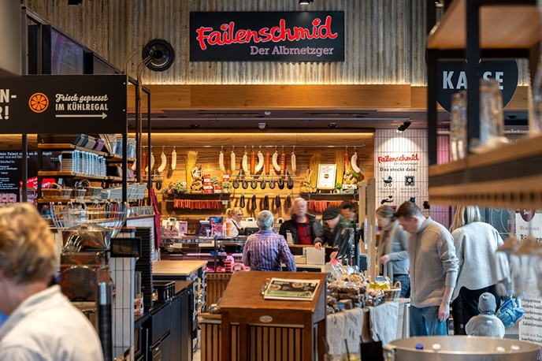
Albmetzgerei Failenschmid sells around 120 sausage varieties in its shop in Gächingen and at the H-Albzeit service station on the A8 motorway.

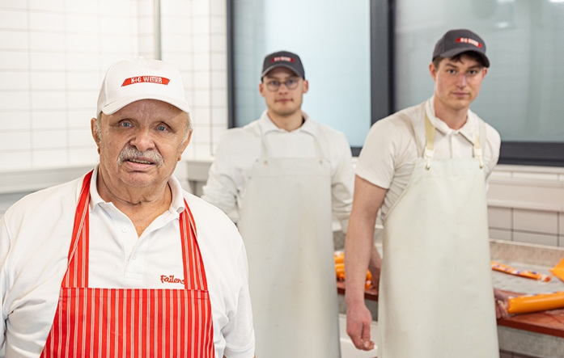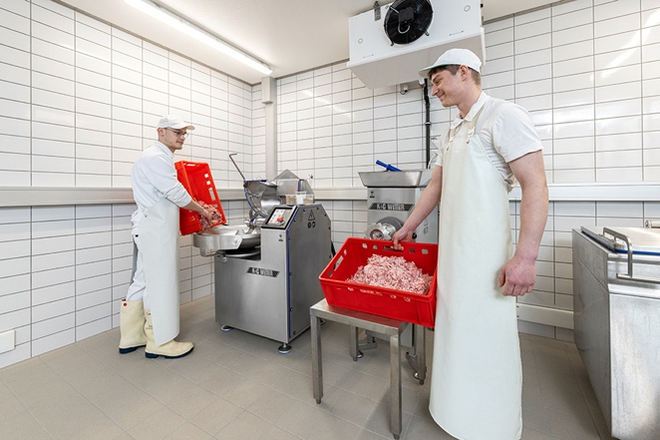
Ensuring that 300 years of butchery tradition also has a future: instructor Edgar Kuhn and the Failenschmid apprentices Simon and Magnus working in the company’s own training workshop with the SM 33 bowl cutter and the EW 98 electric grinder from K+G Wetter.

