PRESS INFORMATION
K+G Wetter, January 2026

K+G Wetter expands management team with Jost Wetter and Marco Beimborn
Food machinery manufacturer K+G Wetter is setting the course for the next generation and expanding its management team. Jost Wetter and Marco Beimborn joined the management team of the German family business in January 2026. Together with Andreas Wetter and Volker Lauber, who will remain on the management board, they will lead the company into a future-oriented third generation.
‘Our goal is to develop K+G Wetter with foresight while preserving the values and quality that have distinguished our company for decades,’ says Andreas Wetter. ‘With my son Jost and our long-standing operations manager Marco Beimborn, we are bringing two employees into the management team who know the company inside out, live and breathe responsibility and at the same time bring fresh impetus for new developments.’
Volker Lauber also emphasises the strategic value of early expansion: ‘Through close cooperation in management, we are ensuring that the future handover will run smoothly and that K+G Wetter will remain successful in the long term.’
Jost Wetter (36) is a trained industrial foreman and has been working in the family business since 2011, among other things as head of the sheet metal processing department. Several years in customer service have sharpened his eye for customer requirements and needs. ‘It is important to me that our customers and sales partners worldwide can continue to rely on us and the quality of our cutters, grinders and mixer grinders,’ says Jost Wetter. ‘In addition, continuing our reliable customer support is a high priority for me.’
Marco Beimborn has been operations manager at K+G Wetter since 2014 and previously held various responsible and managerial positions in mechanical engineering. The 51-year-old mechanical engineer and master craftsman brings with him a broad technical knowledge and sound practical experience. This combination forms the basis for his strategic and at the same time practical management style. ‘My aim as managing director is to continue to lead the company in a reliable and prudent manner. At the same time, I want to build on the continuous growth of recent decades and, in particular, drive forward new developments that offer our customers clear and tangible added value,’ explains Beimborn.

Press Photos / K+G Wetter:
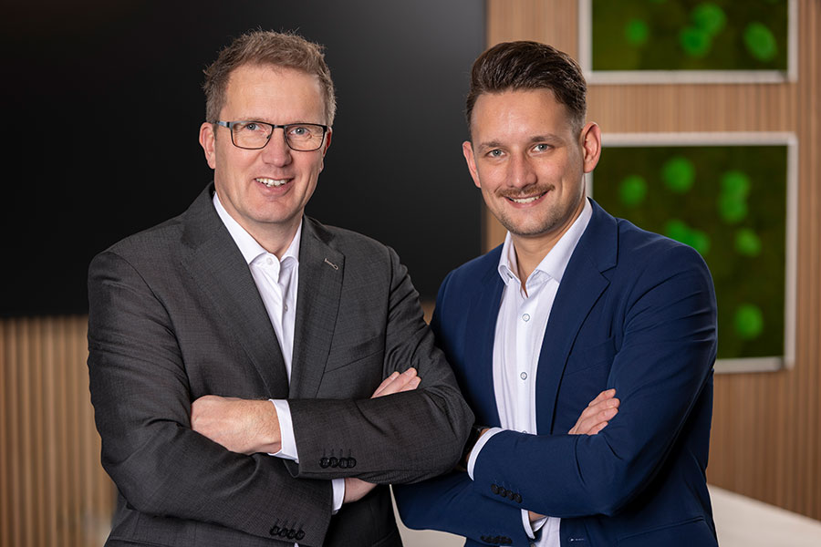
Photo (K+G Wetter): Marco Beimborn (left) and Jost Wetter have been strengthening the management team at K+G Wetter since 1 January 2026.
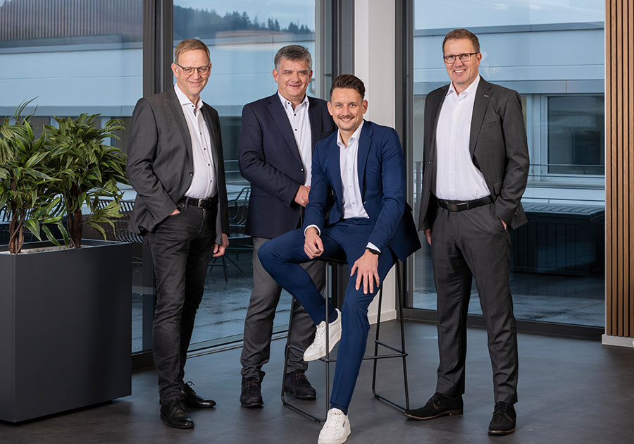
Photo (K+G Wetter): Together with long-standing managing directors Andreas Wetter (centre) and Volker Lauber (left), Jost Wetter (front) and Marco Beimborn are leading the family business K+G Wetter into the future-oriented third generation.

