PRESS INFORMATION – CASE STUDY

K+G Wetter GmbH, Goldbergstr. 21, D-35216 Biedenkopf-Breidenstein

April 2025

**Where the little things have been making the difference for almost 100 years**

**German butcher Klein relies on K+G Wetter mixer grinder and two vacuum cutters**

“Klein” (i.e. small) is just the name in this family-run butcher's shop in Kronberg am Taunus in the wider Frankfurt region in Germany: product quality and appreciation of employees, company tradition in its fourth generation, and being open to new ideas are large at Metzgerei Klein.

And so, it is the details that make the difference: the perfect combination of teamwork and quality awareness, of product diversity and new sales channels. And not least the right technology. These are the small things that have been crucial to the success of the traditional Klein family business since 1926.

**The Klein butchery is now in its fourth generation**

The butcher's shop was founded by the great-grandfather of the current owner: Viktoria Klein took over the business in 2024 together with her brother-in-law Felix Klein. The 26-year-old was top of her class in her training, passed her master's exam in 2017 – and at just 18 years old, was the youngest master butcher in Germany at the time. There is no shortage of female role models in the history of the Klein butcher's shop: “My great-grandmother Franziska Klein's strong work ethic helped the business to flourish, and she was very dedicated to the company. After the early death of my great-grandfather, she had to run the company alone and did so very successfully. She was a very good entrepreneur and remained the branch manager in Oberursel until her death at the age of 80,” says Viktoria Klein proudly. Viktoria Klein's grandmother Brigitte was also an energetic supporter and, after the death of Josef Klein, was crucial to the successful continuation of the business. “A leadership personality always has a significant influence on a company. In my opinion, however, gender does not play a decisive role in this,” emphasizes the young entrepreneur. “Much more important are character traits, willpower and sensitivity towards colleagues.”

**New management, new vacuum cutter**

Since 2024, management has been in the hands of the fourth generation of butchers in the Klein family. And shortly after Viktoria and her brother-in-law Felix Klein moved into the production premises, a new cutter also arrived. The VCM 120 vacuum cutter from K+G Wetter, which has been in operation since 2017, has now been joined by the VCM 70 a few months ago. “Until then, we had a CM 50, also from K+G Wetter. It worked perfectly, but it had become too small, and we lacked the vacuum function and the unloader,” explains Viktoria Klein. Another reason for the new purchase: the greater flexibility when processing different batch sizes and the reliably consistent quality with two machines of the same type. “If you sometimes work with and sometimes without a vacuum, the products and results are simply too different,” says Viktoria Klein, admitting: “Product quality is one of our top priorities, we don't compromise on it.” K+G Wetter took the CM 50 in part exchange and reconditioned it. “It was sold immediately. Our factory-reconditioned trade machines are in high demand on the market,” says Heiko Schneider, the responsible area sales manager at K+G Wetter.

In the production rooms of the Klein butcher's shop, the new VCM 70 is right next to the larger VCM 120. “There are some functions that I no longer want to do without,” emphasizes Viktoria Klein, who has also already experienced the predecessor machines from K+G Wetter in operation. “To name just a few examples, the loading system for meat trolleys on the VCM 120, the shutdown function according to rounds and temperature, and the vacuum function on both cutters. Then there's the slim design, which simply gives you more space to work around.”

**Three machines at a glance**

At the Klein Butcher's, this is particularly beneficial for Operations Manager Christian Bauer. The master butcher operates both vacuum cutters simultaneously: He loads meat and other ingredients, starts the processing, keeping an eye on all the parameters, and pushes the finished sausage meat into the full meat trolley for filling. For this to work so well, Christian Bauer's experience and expertise are required, but so are the well-thought-out technical K+G Wetter features. In addition to the bowl cutters, Christian Bauer also works with the MWW 130 mixer angle grinder from K+G Wetter.

**Technology supports product quality**

In the case of the two cutters, the master butcher is currently producing cooked sausage meat using the all-in method. In contrast to the build-up method, in which meat, fat, spices and other ingredients are added to the cutter bowl one after the other and processed step by step, Christian Bauer fills the cutter directly with all the raw materials for the sausage meat. The complete quantity of ice is also included. “First of all, the mass is naturally very cold, and it takes a little longer to reach the desired temperature. On the other hand, the intermediate steps are eliminated, and I only have to vacuum once. This saves time and energy,” explains master butcher Bauer. And on the subject of vacuum: “I work here with a 30 percent vacuum for this sausage meat. This gives the sausage a perfect consistency that is not too firm.” Using the touch panel of the K+G Wetter bowl cutter, Christian Bauer has previously specified that the processing of the sausage meat automatically switches off after a certain number of bowl rotations or when a maximum temperature is reached. In the K+G Wetter bowl cutters, the temperature sensor is located directly in the cutting chamber – this provides particularly reliable protection against quality loss due to sausage meat being overheated, because this is where the knives generate the energy, causing the temperature to rise.

The fact that the machines are so smart is what makes it possible to work with two bowl cutters and a range of different products at the same time. This is the only way that Christian Bauer can produce five to six batches in an hour using the VCM 120 and a further five using the VCM 70 in parallel, which are then passed on to colleagues in the filling area.

Both the VCM 120 and the VCM 70 are part of the Hygienic Secure series from K+G Wetter. These machines have been designed right down to the last detail for quick and easy hygiene cleaning: all stainless-steel surfaces are perfectly polished and sloped so that water runs off without leaving any residue after cleaning. So, the machines do not provide a breeding ground for germs. Parts such as the knife cover strips, bowl scrapers or the knife cover support can be quickly removed and reinserted for cleaning. Last but not least, large cleaning flaps in the vacuum chamber provide easy access and thorough cleaning below the bowl.

**Machine development in cooperation with practitioners**

“From our point of view, there are no issues here,” reports Viktoria Klein. Not without pride, because the Klein Butcher's was one of the first butcher's shops to work with each of the new vacuum bowl cutters. K+G Wetter also fulfilled some special technical requests for the bowl cutters in the Klein sausage kitchen. “It's a privilege that we were able to put the machines into operation so early and incorporate our individual suggestions,” adds Klein plant manager Christian Bauer. This underlines how much K+G Wetter's development of the machines and features is geared towards what is really beneficial for work and product in the daily practice of butchers.

Another example: the vacuum cutters at the Klein butcher's shop use CutCounter. Developed by K+G Wetter, this smart digital assistant keeps a close eye on the number of cuts made with a set of knives. The result: knives can be replaced before they become blunt, ensuring that the quality of the sausage meat remains consistently high. Additional costs due to higher energy consumption and wear are also avoided.

The third K+G Wetter machine in the meat processing department of the Klein butcher's shop has been the MWW 130 Easy Access mixer angle grinder since 2018. “It runs perfectly and does its job absolutely reliably day after day,” says Viktoria Klein happily. “This is where, for example, Mett or our Mettwurst is produced.” The MWW 130 is also indispensable for minced meat or corned beef.

**Artisanal, regional, proven**

On the product side, Viktoria Klein, as a master butcher, can see at a glance the difference that the sophisticated technology has made to the sausage varieties: “The machines work gently, and all the varieties simply look good when sliced.” 95 percent of the products displayed in the Klein branches in Kronberg and Oberursel, waiting to be enjoyed by customers, are produced in-house. “The words ‘handcrafted’ and ‘regional’ describe our products very well. Not least because we produce in the center of Kronberg itself. And with a few exceptions, our meat comes from farmers within a 40-kilometer radius,” says the young entrepreneur, adding: ”But we also want to offer proven regional specialties such as Black Forest ham or the “Ahle Wurst” sausage from the north of Hessia, that we are not allowed to produce ourselves.”

**Branch store and online shop**

For some time now, the Klein butcher's shop has no longer relied solely on the success of its branches to sell meat and sausage. “Our online shop ([www.metzgerei.de](http://www.metzgerei.de/)) was created two years ago at the request of former customers,” recalls Viktoria Klein. “Many of our customers who have moved away have written to us again and again over the years because they can no longer get the quality of our products at their new places of residence. We were happy to meet this demand.” The Klein online shop is as individual as shopping in a local store: “If you want four slices of cold cuts, you get four, and if you want five, you get five. We try to make everything possible for our customers here – not like other online shops, where you often have to buy meat by the kilo. This doesn't make the process and handling easier for us, but at least the customers gets exactly what they want.” It's no wonder that the online shop is becoming increasingly important for the Klein butcher's shop and that regular customers from all over Germany are pleased with the fast and uncomplicated delivery of sausage and meat from Kronberg directly to their front door.

**The Klein butcher's shop**

In addition to the machine technology, the people in the family business are crucial for product quality and success. Founded in 1926, the Klein butcher's shop is now in its fourth generation and has around 70 employees. “Our colleagues are valued and listened to, enjoy working here and are therefore particularly committed,” says Viktoria Klein, explaining what makes the company special. “This helps with product quality, where we make no compromises, but also when dealing with customers.” And even though the two young owners are no longer actively involved in production themselves: “Being close to our colleagues is particularly important to us. That's why we visit the branch every day and are on hand when we're needed. And if there's an emergency, we naturally help out in production or sales. This is a matter of course for us, even though it's no longer done in most companies of our size.”

**Photos: K+G Wetter + Metzgerei Klein**

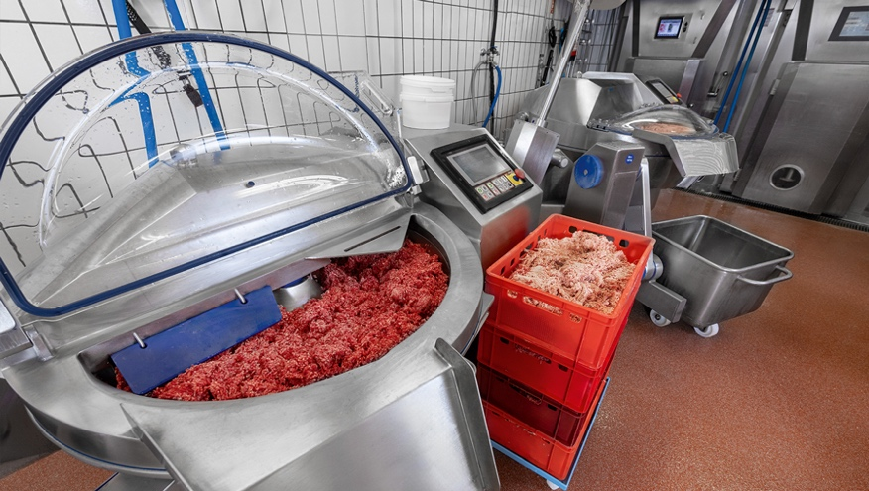

The centerpieces of the Klein sausage kitchen are the vacuum cutters VCM 120 (back) and VCM 70 (front) from K+G Wetter.

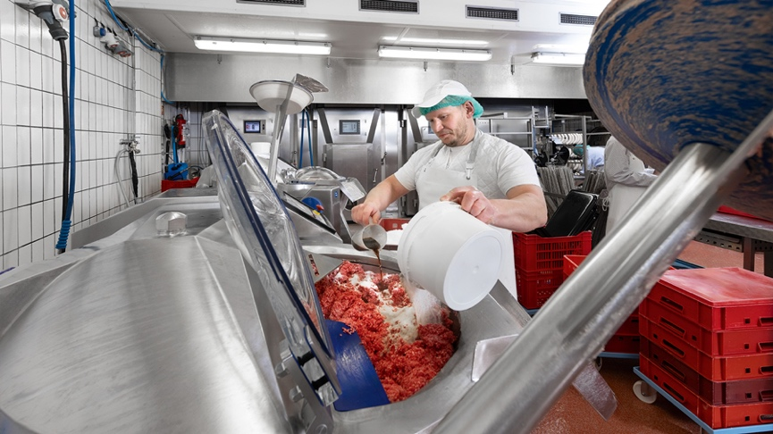

Operations manager Christian Bauer adds all the ingredients to the cutter bowl at the very start of processing with the all-in cutters.

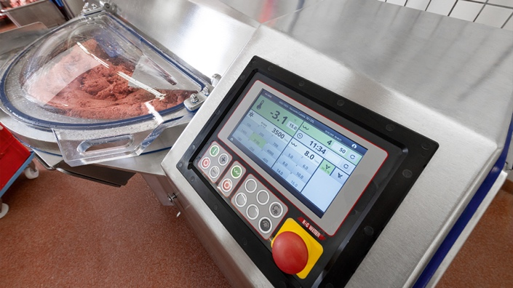

The processing is precisely controlled with the clear touch display, here on the VCM 70, including a switch-off function, for example, after a set time, target temperature or bowl revolutions.

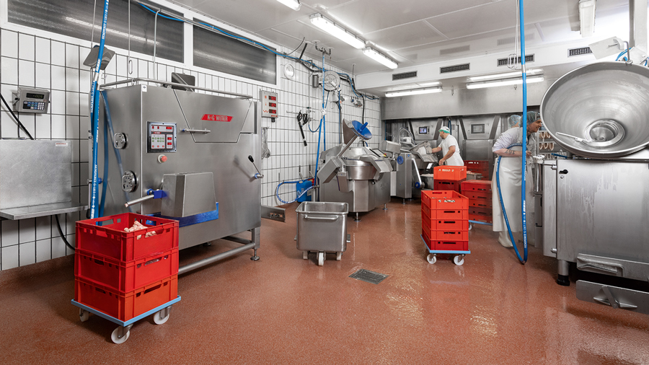

Image Z4A1993.jpg: Operations manager Christian Bauer (back) operates the MWW 130 mixing angle grinder and the two vacuum cutters from K+G Wetter simultaneously. Compact machine design and clever technology make it possible.

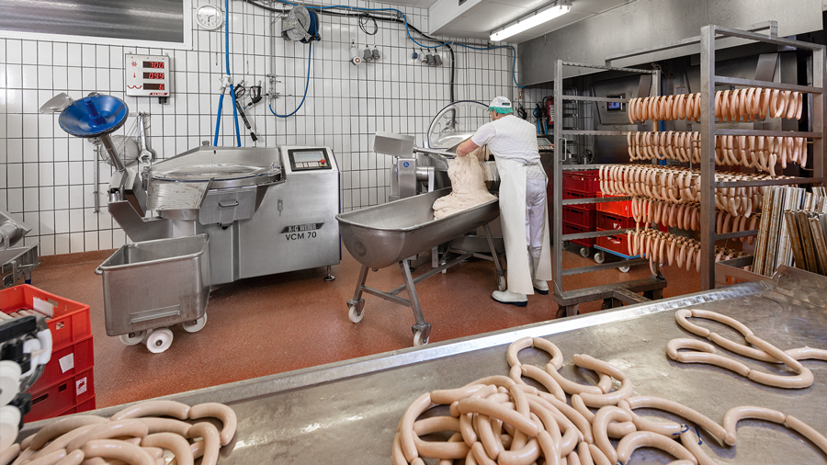

Photo Z4A2048.jpg: From five to six batches of sausage meat per bowl cutter and hour, the Klein butchery produces a large quantity of delicious sausage specialties for the shop and online shop every day.

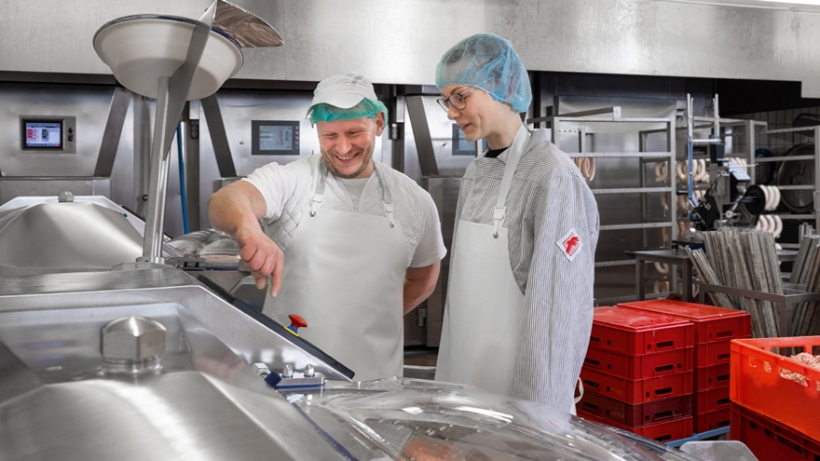

Training in the family business: Operations manager Christian Bauer explains to intern Lena Klein, niece of senior partner Richard Klein, how the VCM 70 works.

Photo: Metzgerei Klein

Ein Bild, das Person, Kleidung, Essen, Menschliches Gesicht enthält.

Viktoria and Felix Klein (front) with their predecessors and senior directors Richard and Harald Klein (back)