PRESS INFORMATION – CASE STUDY
K+G Wetter GmbH
Goldbergstr. 21
D-35216 Biedenkopf-Breidenstein

February/March 2025

Powerful cooking cutter for Bavarian delicacies in XXL quantities
Munich's traditional butcher Magnus Bauch relies on K+G Wetter technology

10 to 15 tonnes of production volume daily, at least one tonne of white sausage a day – but this is not a large food company, but a traditional Munich family butcher's shop with a long tradition of handcrafted products.

The shop front on Thalkirchener Straße is classically simple, with red neon lettering. The entrance to the butcher's shop and snack bar is on the right, and a narrow door to the retail area is on the left. It is only when you go further back that you can guess how big the Magnus Bauch butcher's shop really is. The production rooms extend over the entire area of two large town houses – and two storeys deep into the Munich underground. For more than 70 years, meat specialities have been produced here for shops, innkeepers and customers from Munich and far beyond. Thanks to the Magnus Bauch butcher's shop, guests at the Oktoberfest, at the Käfer markets or at the snack counters at Munich bakers can enjoy delicious food from the sausage kitchen day in, day out. And because hearty Bavarian food and the Oktoberfest and beer garden culture are also popular internationally, guests from London to Grenoble enjoy white sausage and meat loaf, bratwurst and cold platters from Magnus Bauch.
Cooking cutter and mixer grinder from K+G Wetter
What is needed for the numerous boiled, cooked and raw sausage specialities in terms of sausage meat is produced almost exclusively with two machines from K+G Wetter: In addition to the MWW 130 mixer angle grinder from the German meat processing machine specialist, a Cutmix 360 has also been in the production room at the Bauch butcher's since May 2024. The special feature: the open cooking cutter enables the production of cooked sausage even without a vacuum function. This is a feature that is only available from K+G Wetter, as Sales Manager International Volker Schlosser emphasises: ‘For customers whose products benefit less from vacuum technology, we have our industrial cutters with the cooking device from the Hygienic-Secure series. This makes the machines very interesting from an economic point of view, as we no longer necessarily need the elaborate construction of a vacuum cutter to use the cooking function. This reduces costs enormously.’ The unique solution that K+G Wetter has developed for particularly hygienic and energy-saving cooking is a double-walled cooking bowl. Thanks to the closed system, the steam supplied heats the cutter bowl only via the space between the two bowl walls, very quickly and in an energy-efficient manner. The fact that the steam also remains completely separate from the processed product guarantees 100% hygiene: there is no risk of contamination from water vapour.
Cooked sausage with full flavour
Plant manager Rudi Hischa explains the advantages of the bowl cutter designed especially for cooked sausage varieties. The master butcher has been working at Magnus Bauch for almost half a century, his entire professional life. ‘The alternative for liver sausage would be to pre-cook the ingredients in a kettle. But of course, then some of the flavour and ingredients are lost in the cooking water. What's more, there are significantly more steps involved in filling, heating, cooling and decanting,’ explains Rudi Hischa. The new bowl cutter prevents cooking losses and preserves all the valuable ingredients, such as protein and minerals. Since the open cooking cutter combines all the functions in a single device, many intermediate processing steps are also eliminated. In addition, no wastewater containing fat and protein is produced.
At the cutter, master butcher Josip Jukic, one of around 80 employees at Magnus Bauch, is currently preparing a batch of veal liver sausage. Step one: a meat trolley full of veal liver is pre-cut into a fine mass in just a few minutes – but still in a cold state. ‘The raw veal liver is added later to the rest of the cooked and cooled sausage meat. If you were to cook the liver with the other ingredients or add it to the sausage meat that was too hot, the protein would denature and the liver sausage would not bind,’ explains Rudi Hischa. At the bowl cutter, Josip Jukic now removes the rather liquid veal’s liver mixture from the cutter bowl – this is quick and clean with the hydraulically driven ejector of the K+G Wetter cutter. In the next step, the master butcher adds meat and spices and starts the cooking process. To ensure that the sausage meat cooks gently during the grinding process, the double-walled bowl of the CM 360 is heated to 72.5°C with steam introduced into the intermediate space. Incidentally, the temperature sensor in the K+G Wetter bowl cutters is located directly in the cutting chamber and records the temperature very precisely – where energy is also introduced via the knives. And that's not all: with these sensors and thanks to the intelligently controllable steam valves of the CM 360, the amount of steam can be precisely regulated according to the current temperature of the food being cooked. This ensures short process times and is particularly economical and energy efficient. The fact that no excess steam escapes from the machine also improves the room climate in the sausage kitchen. The amount of water flowing through the bowl during the cooling process is also controlled according to the temperature of the cooked product: the water does not flow continuously, but only in the amount needed for optimal, rapid cooling of the sausage meat.
Afterwards, thanks to the double-walled bowl, the open cooking cutter also ensures that the sausage meat quickly cools down again to the 45°C required for further processing. Cold water flows through the space between the bowls for this purpose and the sausage meat is quickly ready for the last processing step in the cutter: the prepared liver mass is now added to the bowl and is gently incorporated for several minutes. The raised bowl edge, which is standard on all K+G Wetter bowl cutters, proves its worth here: although a good 360 kilograms of sausage meat is turned in the 360-litre bowl, nothing spills over. The result of technology and craftsmanship: a finely glossy, perfectly bound emulsion that will soon be ready to be packaged in the Magnus Bauch butcher's shop next door and later on the customers' lunch boards, where it will ensure many a moment of culinary delight.
CutControl makes Leberkäs reliably good
The next item on the production list at the Magnus Bauch butcher's shop is a Bavarian classic: Leberkäs. Here, the cooking function is paused. Rudi Hischa has stored the Leberkäs recipe in CutControl, as almost all of the family business's recipes now are. The ingredients and detailed information on preparation, such as bowl revolutions, knife speed, times and temperatures, are stored in the recipe management and production control programme developed by K+G Wetter. ‘We have four butchers working on the bowl cutter,’ explains the plant manager. ‘And each of them has their own experience and processing techniques. You can simply taste it in the product. But we have to have a standard, these differences have to go,’ explains Rudi Hischa. He and his team are convinced by CutControl: “The most important thing is simply that our products have consistent quality in terms of flavour and consistency.”
Sorting device at the grinder as the basis for quality
The MWW 130 mm does important preparatory work in the sausage kitchen at Magnus Bauch: a large proportion of the meat is pre-processed in this mixer angle grinder in the first step. The pneumatic sorting device reliably sorts out hard parts – a real plus in terms of quality. The ClearCut sorting and meat knives developed by K+G Wetter and only available for K+G grinders are in use: ‘This really does produce a clearer cut and, above all, the salami looks better when sliced,’ says Rudi Hischa.
Simply hygienic
From time to time, and especially at the end of a single shift of production at Magnus Bauch, the CM 360 shines again – thanks to well-thought-out hygiene features: The sloping stainless-steel surfaces can be perfectly hygienically cleaned. Components such as the knife cover support or bowl scraper can be removed from K+G Wetter cutters for cleaning in one easy step, as can the knife cover strips. ‘What's really great is the cleaning time. Everything is well made, you can get everywhere to clean it. The bowl, the sides, everything is easily accessible, that’s great’, enthuses Rudi Hischa, whose employees do all the cleaning work in the company themselves.
A mature business partnership
Looking back, Rudi Hischa explains the decision against a vacuum cutter from K+G Wetter as follows: ‘We manage well with our products without a vacuum. We also worked without a vacuum cutter for the 70 years before that and so we said, in the end, it's not that important to us.’ Added to this was the low ceiling height in the depths of the old house: the investments necessary for the higher vacuum cutter for the conversion were disproportionate to the benefits. However, it quickly became clear that it should be a cutter from K+G Wetter. ‘This is certainly also due to the way the company is managed, the personal contact and the fact that there was always someone on hand when we needed something. We also got offers from other companies, that's for sure, but in the end, we actually agreed that we would go with K+G Wetter again.’ Another plus point: whether cooked, boiled or raw sausage, the sausage meat for Magnus Bauch's specialities comes from the CM 360. ’We also chose K+G Wetter because the cutter is so multifunctional.’
The collaboration proved its worth as soon as the cooking cutter was installed: Getting the large machine through narrow access points and around several corners into the Bauch sausage kitchen required a lot of experience and a logistical tour de force.
First hit for the K+G Wetter industrial cutter
Incidentally, the CM 360 from K+G Wetter passed its first major test right at the beginning of its time in use at Magnus Bauch: for the Soccer European Championship in Germany in the summer of 2024, there was a short-term order for several tonnes of currywurst for the fans in the stadium. Since then, the industrial cutter has produced the basis for several hundred tonnes of Bavarian delicacies at the family-run business Magnus Bauch and is well equipped for the barbecue and beer garden season. Whether in Munich or anywhere else where delicious hearty food is on the menu.
Press photos: K+G Wetter
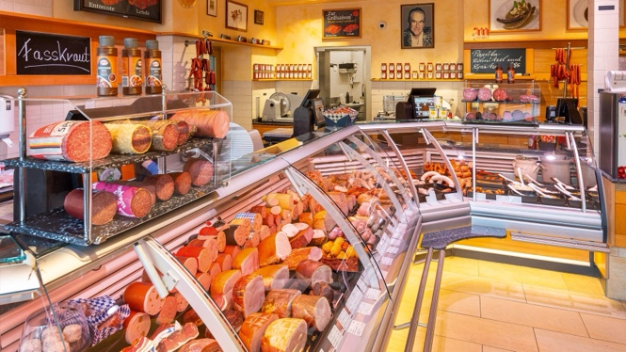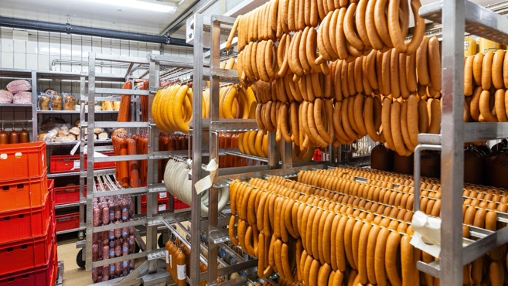
Hearty food from Magnus Bauch for butchers and retailers

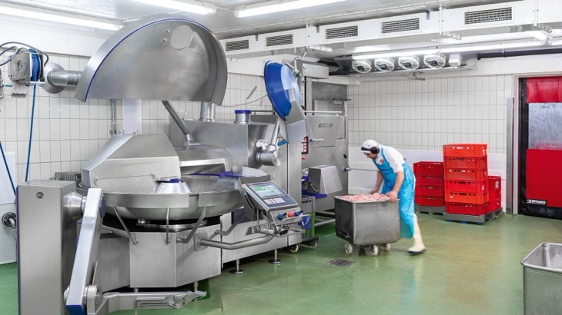
Master butcher Karl Bergbauer brings the pre-minced meat for the veal liver sausage from the MWW 130 (rear) to the CM 360.

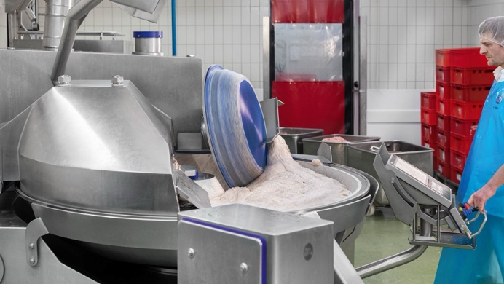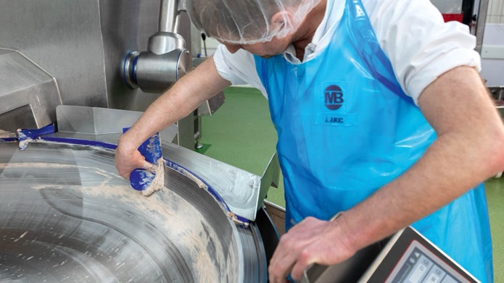
Master butcher Josip Jukic decanting the finished Leberkäs meat. Even for intermediate cleaning, everything is easily accessible.

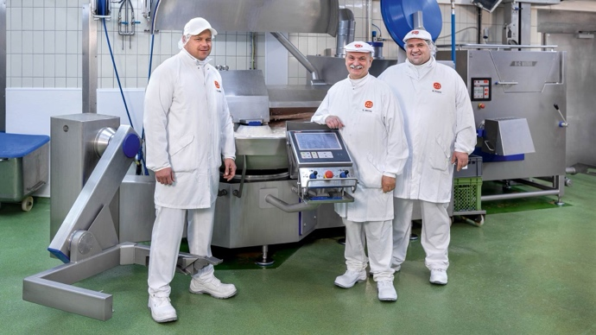
Operations manager Rudi Hischa (centre) has been with the Magnus Bauch butcher's shop in Munich for 48 years. Like his co-managers Maximilian Aigner (right) and Rainer Jobst (left), he is convinced by the K+G Wetter mixer grinder and cooking cutter.
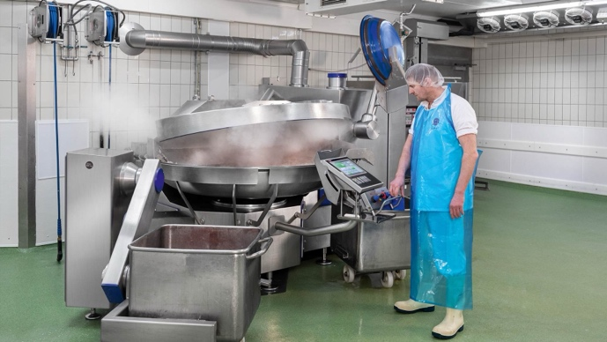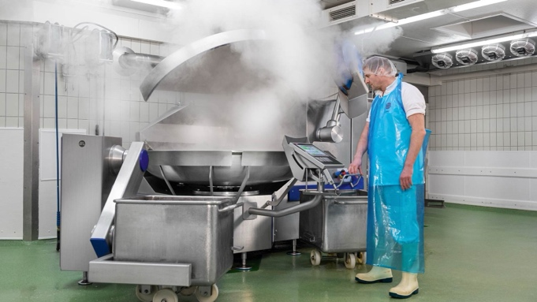
Thanks to the water cooling of the double-walled bowl, the meat for the veal liver sausage, which is cut and cooked in the CM 360, quickly returns to the correct temperature for the addition of the liver, which is already in the hydraulic loading system.
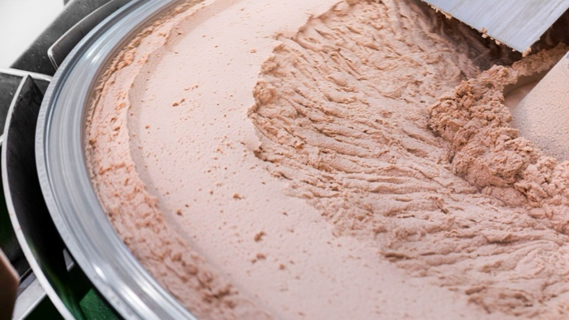
Thanks to the raised edge of the bowl, the bowl volume is fully utilised. A good 360 kilograms are processed in the 360-litre bowl at the Bauch butcher's.

