PRESS RELEASE
K+G Wetter GmbH
November 2024

Wolfpack butchers with K+G Wetter on the way to defending their title in Paris
For World Championships the team relies on cutter from German specialist

Countdown for Mission Gold: when the best butchery teams compete for the World Championship title in their profession on 30 and 31 March 2025, the defending champions from Germany will also hit the start line: the Butcher Wolfpack, the 2022 World Champions, aim to defend their title at the 2025 World Butchers’ Challenge. Joining them as team member in Paris: the cutter SM 33 from K+G Wetter.

The meat processing equipment specialist from Germany already supported the wolves in their 2022 World Championships victory in Sacramento (USA). And in 2025 in Paris, K+G Wetter is once again supporting the motivated team with a gold sponsorship.

Captain Dirk Freyberger and his wolf pack want to impress the WBC jury of experts in the exhibition halls of the French capital once again with world-class products that are expertly processed. And the majority of his fellow wolf pack members are very familiar with K+G Wetter's machines.

Master butcher Matthias Endraß, for example, works with the CM 50 STL from K+G Wetter. The meat specialist from Bad Hindelang in Bavaria was already part of the 2022 World Champion team. He produces many specialties in the compact trade bowl cutter that became indispensable in his world-class sausage kitchen and impresses with perfect handling: from the variable cutting speed and precise control to the increased bowl rim for full utilization of the bowl volume and the optimal cleaning properties.

Another plus: the low-vibration and quiet running – a feature that the cutter shares with the equally robustly built smaller SM 33, which the Wolfpack is taking to Paris. Staying calm even at full power – that's how the K+G Wetter cutter and the Wolfpack's WBC title defenders are a perfect team!

K+G Wetter

Butcher Wolfpack

Photos: K+G Wetter

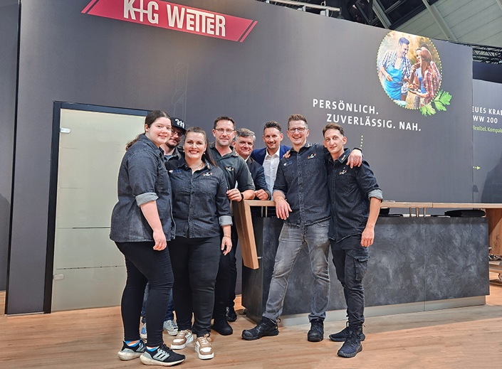

Andreas and Jost Wetter (back row, center) welcome Wolfpack team captain Dirk Freyberger (2nd from right) and members of the Butcher Wolfpack to the K+G Wetter stand at SÜFFA 2024.

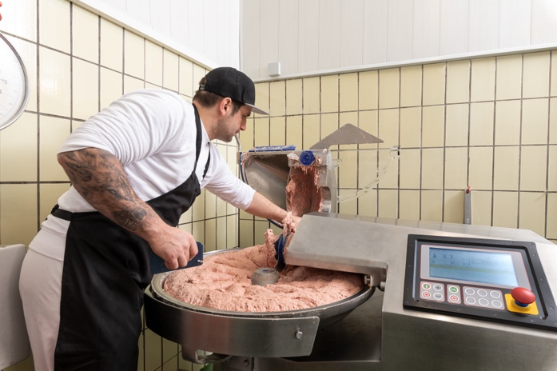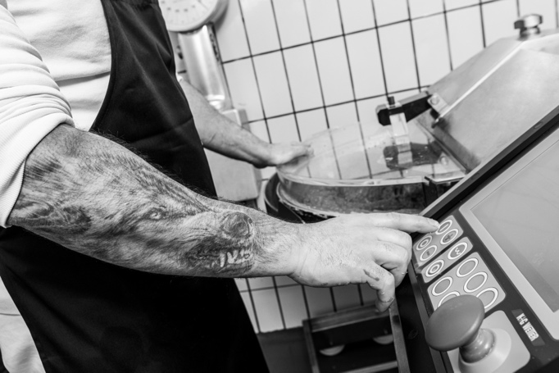

Master butcher Mathias Endraß, WBC title defender with the Butcher Wolfpack, works with the CM 50 from K+G Wetter

