PRESS RELEASE
K+G WETTER GmbH
April 2020

Strongly positioned for the future
K+G Wetter expands its production area once again

Innovation means progress. The experts at K+G Wetter are aware of this too. The specialist manufacturer of meat processing machines provides its customers with quality derived from tradition. In order to continuously optimise internal work processes and respond capably and comprehensively to individual customer requirements worldwide, the company is constantly working on optimising its internal processes. At its site in the Breidenstein district of Biedenkopf, in the German State of Hesse, a new production hall with an area of 1,500 m² is currently under construction.

Expanding the production area not only creates more space – it also facilitates the constant optimisation of internal work processes. This is already the second new building to be constructed following the hall extension in spring 2018. Completion is slated for mid-2020 and the project will deliver additional space for the production of large-scale machines for the industry, for which demand is growing steadily.

Flexible and competent
“This further expansion of our production facilities represents another milestone in our corporate history, because we will have more space available in future for manufacturing our machines. This will make us even more flexible and capable in operation. Our aspiration is to always address our customers’ individual requirements in a competent and reliable manner”, says Andreas Wetter, Managing Director of K+G Wetter.

K+G WETTER GmbH
K+G Wetter is a sought-after global partner for manufacturing high-quality and reliable meat-processing machinery. K+G Wetter develops advanced cutters, grinders and mixers for butchers and skilled workers in the meat-processing trade and industry. The company's sophisticated technology and high-quality processing mean that machines from K+G Wetter contribute significantly to customers' business success. As a world-famous brand, the company from the Breidenstein district of Biedenkopf, in the German State of Hesse, supports its customers with personal and individual advice.
www.kgwetter.de

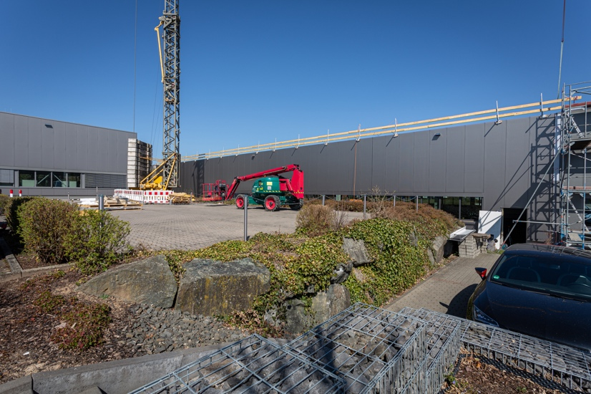
Press image 1:

© K+G Wetter
Picture caption: K+G Wetter continues to grow: At its site in the Breidenstein district of Biedenkopf, in the German State of Hesse, a new production hall is under construction, with completion slated for mid-2020.

Press image 2:
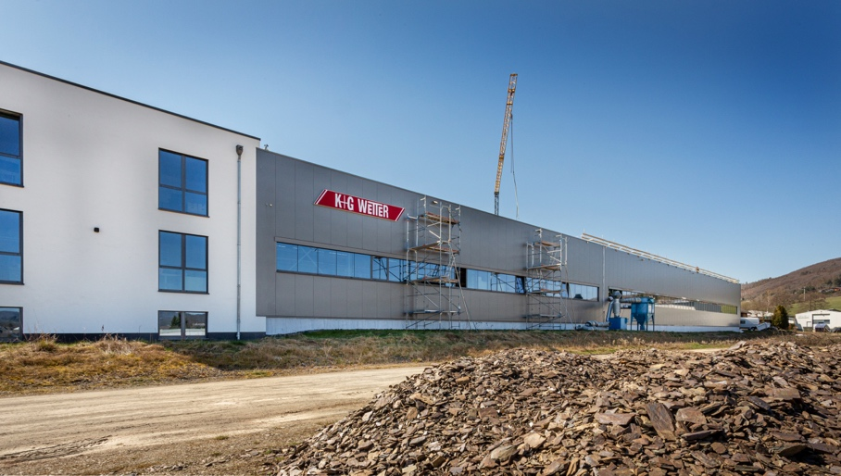

© K+G Wetter
Picture caption: Work on the new hall is currently underway. This is already the second new building to be constructed since 2018.

Contact information:
K+G WETTER GmbH
Goldbergstrasse 21
35216 Biedenkopf-Breidenstein
www.kgwetter.de

Your contact partner:
Katharina Hennig
PR/Media
T. +49 (0) 2 71 . 77 00 16 – 160
F. +49 (0) 2 71 . 77 00 16 - 29
k.hennig@psv-marketing.de
www.psv-marketing.de

