PRESS RELEASE
K+G Wetter GmbH
29/06/2018

Technology from Hesse for Organic Enjoyment from Bavaria
As one of the largest organic meat producers in Upper Bavaria, Packlhof relies on solutions from K+G Wetter

The organic sector is booming – and at Packlhof, about 35 kilometres south of Munich, the reason for this is immediately clear to everyone. Idyllically situated on Lake Starnberg, with a majestic view of the Alps, cows grazing peacefully in the pasture, like in a picture book, and chickens eagerly scratching in the straw. The fact that this is the right path was already recognised by Josef Urban in 1981, and, as a "green visionary", he subsequently switched his business to a natural cultivation. Instead of quantity and medication, the knowledgeable farmer now focuses on quality and pure enjoyment. With success: Packlhof is one of the largest organic meat producers in Upper Bavaria today, and has made a name for itself far beyond the region thanks to numerous awards and its trading partner Alnatura. You can look in vain for nitrite pickling salts and additives in the Bioland-certified meat and sausage products. But there is one thing that Packlhof cannot and does not want to do without: modern technology that meets the high demands placed on the production of high organic quality. That is why the Bavarians maintain a special relationship with neighbouring Hesse, home to the headquarters of K+G Wetter.

Uncompromising quality
"The company's reputation worldwide naturally also reached our ears. And because we do not compromise on quality, it soon became clear to us that K+G Wetter was the right partner for us. In addition, we share common values, because both K+G and ourselves have pure enjoyment as our ultimate goal, "says Florian Holzmayr. Since the sudden death of his father-in-law, Josef Urban, two years ago, the master butcher has successfully continued to run the family business together with his wife, and has stayed true to the course first taken by Urban. As a result, spirits are high when Florian Holzmayr leads us through the in-house production site in Eurasburg, three kilometres from the Packlhof main site. The employees at the machines laugh and joke, while the new vacuum bowl cutter from K+G is running at full speed and is already turning meat into the finest organic salami. As the creative head of the company, Florian Holzmayr came up with the recipe for this, and then transferred it directly from the PC to the machine.

"The Cutcontrol software from K+G was quite certainly decisive for the purchase of our bowl cutter," said the 36-year-old. "It ensures efficient processes and guarantees exactly the same quality because it guides our employees through the production process step by step. And that's much more important to us than it is for regular meat processing because we do not offer anything off the shelf. "The software is easy to operate via the touch panel, which is standard equipment in all K+G trade bowl cutters. Frequently used commands such as the opening and closing of the knife cover are placed on prominently placed illuminated ring keys, other commands are quickly activated in turn by using the panel's clearly-structured display. A further advantage: Due to the software and corresponding settings, the bowl cutter can be stopped automatically, which effectively prevents the accidental over-cutting of the product. "For us, this means that we do not have to constantly stand at the machine to be able to rely on consistent quality."

The highest standards of hygiene
The VCM 120 Vacuum Bowl Cutter processes around three tons of meat day after day. Eight more are running through the grinder, which is also from K+G. "We bought both machines in October 2017 because we know from experience how robust and reliable they are. This is extremely important to us because we cannot afford any failures", emphasises Florian Holzmayr. "In addition, we work to the highest hygiene standards, and so the simple cleaning process for the machines plays a major role for us. And it really is a perfect process." K+G ensures that with lots of clever details. All stainless steel surfaces on the machines are thus designed so that no cleaning water accumulates but simply drains off via sloping planes. In addition, the closed stainless steel cladding prevents dirt from accumulating in small cracks or welds. Dust and moisture reliably remain outside due to special seals on the inspection openings. Another special feature is the special flushing channels behind the rotating components such as mixing shaft, feeder worm or meat worm. Using a hose, the non-accessible area behind the shafts can therefore be rinsed with water and an additional cleaning agent via rinsing connections on the machine body, and cleaned as best as possible. The cleaning water is then simply passed through a drainage channel across the machine floor to the outside.

K+G also makes the work of Packlhof operators easier with other well thought-out ideas. The grinder, for example, has the so-called "Easy Access" entry point, a generous opening to the mixer space, which allows cleaning to be carried out much faster and more thoroughly. The intelligent sorting device also ensures clean workmanship. This sets hard parts to the side, which allows the rejected material to be carefully checked at a glance. For cleaning, the sorting device can then be dismounted and remounted without the use of tools within seconds.
The vacuum bowl cutter also has large cleaning access points. Even cleaning under the bowl, which often requires a lot of time, is quite easy here, because water and cleaning agents can be introduced in a targeted manner. Another plus is the divided noise protection lid. Thanks to this solution, it is no longer necessary to lift the entire lid, only the front area. This provides quick and easy access to the cutter bowl. "We're not getting any younger, either," winks Packlhof employee Julian Kawa as he passes by.

Simply delicious
Some of what leaves the Packlhof production line goes directly to firm's own organic shop next door. It too, of course, just like the farm, butcher's and livestock, is in firm family hands and attracts visitors from near and afar with its delicious treats and the relaxed, feel-good atmosphere. They have a choice between around 250 sausages and meat specialities, and can also stock up on many other organic products. Whether fruits and vegetables, eggs, bread and baked goods, or dairy products: for everything, enjoyment comes first. Of course, after the tour through the production site, Florian Holzmayr does not hesitate to extend an invitation to a taste test. The first bite into the delicious salami immediately highlights the fact that the young manager understands his craft. "By cutting in a vacuum, the taste becomes incredibly intense and we need significantly less seasoning. Instead, we rely on vegetable extracts and, of course, on our skills," grins Florian Holzmayr mischievously, adding: "We have also definitely noticed a difference in terms of consistency with the vacuum bowl cutter. The products are simply more stable in the end."

Since 1992, the rest of Germany has also been able to enjoy fine Packlhof specialities: With Alnatura, the organic butcher has a strong partner at its side which sells its meat and sausage products in selected supermarkets. This also shows the high standards held by the Holzmayr family. For Alnatura insists that all agricultural ingredients of the products they distribute must come from organic farming, and not just the minimum of 95 percent required by German law. No wonder, then, that Packlhof has already won several awards from the renowned Bioland Association. "The next competition is just around the corner, so we're really looking forward to it and, of course, we all work hard", says Florian Holzmayr quickly, before he gets back to work. Back to the PC, where even more delicious recipes are waiting to make their way to the K+G bowl cutter.

K+G Wetter GmbH
K+G Wetter is a global partner of choice when it comes to manufacturing high-quality, reliable meat-processing machinery. K+G Wetter develops innovative bowl cutters, meat grinders and mixers for butchers and skilled operators engaged in the meat-processing trade. The sophisticated technology and high-quality processing features of K+G Wetter machines play a significant role in bringing about customers’ corporate success. An internationally renowned brand, this company from Biedenkopf-Breidenstein in Hesse (Germany) supports its customers by dispensing personalised and individual advice.
www.kgwetter.de

Press image 1:
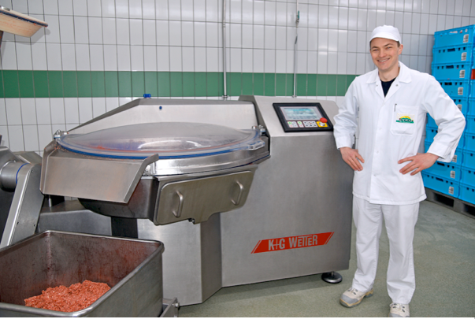
© K+G Wetter
Image caption: Shared values: Butcher Florian Holzmayr relies on quality and state-of-the-art technology from K+G Wetter.

Press image 2:
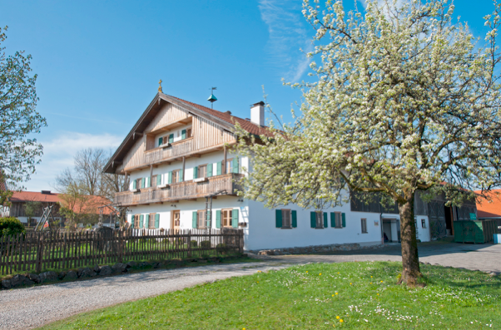
© Vero Design, Karletz
Image caption: The organic sector is booming: Packlhof is one of the largest organic meat producers in Upper Bavaria today, and has made a name for itself far beyond the region thanks to numerous awards.

Press image 3:
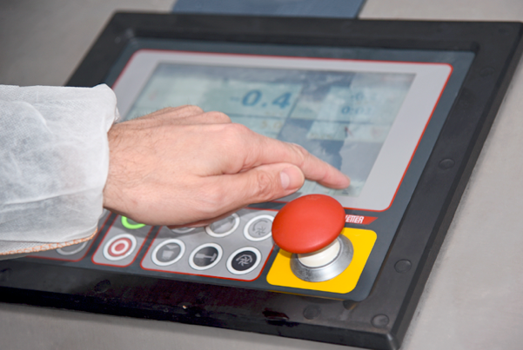
© K+G Wetter
Image caption: The touch panel, which is integrated as standard into all K+G trade bowl cutters, makes it easy to control the Cutvision and Cutcontrol software solutions.

Press image 4:
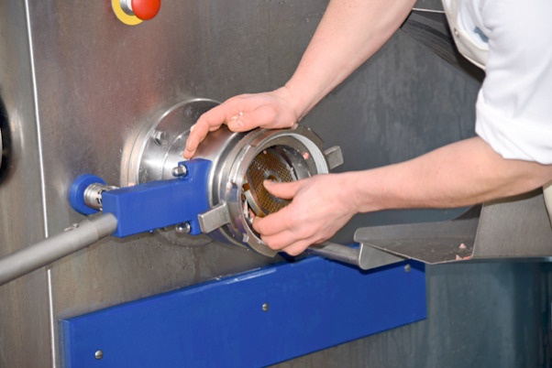
© K+G Wetter
Image caption: For cleaning, the sorting device can then be dismounted and remounted without the use of tools within seconds.

Press image 5:
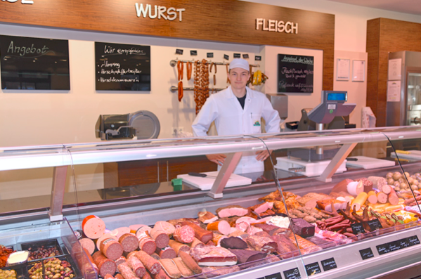
© K+G Wetter
Image caption: Some of what leaves the Packlhof production line goes directly to firm's own organic shop next door. Visitors have a choice between around 250 sausages and meat specialities, and can also stock up on many other organic products.

Press image 6:
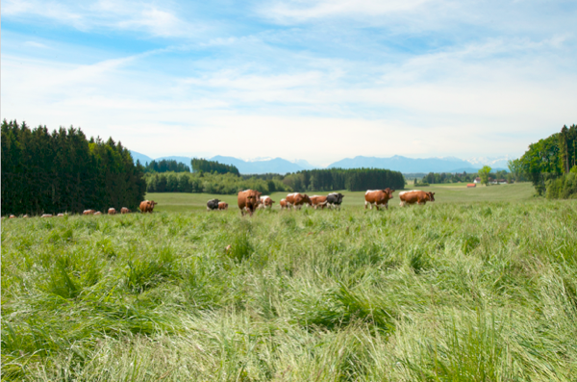
© Vero Design, Karletz
Image caption: Since 1992, the rest of Germany has also been able to enjoy fine Packlhof specialities: With Alnatura, the organic butcher has a strong partner at its side which sells its meat and sausage products in selected supermarkets.

Contact details:
K+G Wetter GmbH
Goldbergstrasse 21
35216 Biedenkopf-Breidenstein
www.kgwetter.de

Your personal contact:
Yvonne Scheurer
PR/Media
T. +49 (0) 2 71 . 77 00 16 - 26
F. +49 (0) 2 71 . 77 00 16 - 29
y.scheurer@psv-marketing.de
www.psv-marketing.de

