PRESS RELEASE
K+G WETTER GMBH
29/03/2018

Clean performance
Excellent technology for hygienic food processing
K+G Wetter wins praise at the Anuga FoodTec with clever ideas for efficient processes, and picks up the Fleischer-Handwerk Award 2018 to boot

Packed with enjoyment – that's what it's all about at K+G Wetter. At the Anuga FoodTec, the experts from Hesse presented their intelligent ideas for the efficient and hygienic processing of food, the essential basis of good taste. Whether meat or seafood, baby food, sweets or pet food: the high-quality machine solutions from K+G Wetter are used successfully in a wide variety of areas – in both trade and industry. The international trade visitors were therefore delighted to use the opportunity to find out about the numerous new developments from the long-established company directly on site. After four eventful trade fair days, Andreas Wetter, Managing Director of K+G, takes stock of events with satisfaction: "We attach great importance to the personal exchange with our customers and were able to gain valuable insights in many intensive discussions. The tangible confidence in us and our ideas makes us proud and we look forward to further advancing progress in food processing."

Divided lid and intuitive controls make it easy
The 120-litre vacuum bowl cutter with its divided lid was very well received. The advantage is obvious: In use, it is no longer necessary to lift the entire lid, only the front section. This makes access to the bowl much easier and renders loading and unloading the bowl cutter much simpler and faster. In addition, the vacuum space in this series has been downsized, which also saves valuable production time.
As standard, the new touch panel, which incorporates modern touch-screen operation with proven push-button technology, is now available as standard in all K+G Wetter trade bowl cutters. Frequently used commands can thus be triggered quickly and easily via prominently placed illuminated ring keys on the controls, for example, the opening and closing of the knife cover or adjusting the speeds. Other commands, in turn, can be controlled directly via the touch panel screen. The optimised menu navigation ensures intuitive operation of the machines and smooth processes.

Powerful software
The Anuga FoodTec audience was impressed by the “Cutcontrol” and “Cutvision” software, which can be effortlessly controlled via the new touch panel. The former leads you through the production process step by step, allowing recipes to be recalled again and again with the same composition and quality. “Cutvision” reliably records all production steps. All measurable quantities, for example, times or temperature profiles, are documented securely and can be read out digitally at any time, whether directly during production, or even months later. So it's easy to keep a reliable eye on all the essentials.

Smart details for clean work
The issue of hygiene plays a crucial role in food processing. Here, K+G Wetter scored points with its "Easy Access" solution, which is installed in the newly developed Angle Grinder and Mixer Angle Grinder E 130 / G 160. The generous opening allows direct access to the hopper, which, in addition to facilitating the work at hand, also makes cleaning much easier. The same applies to the advanced sorting device: this easily removes hard parts from the side, which allows the rejected material to be regulated safely and quickly. Its intelligent development has now been further optimised by K+G Wetter. From now on, the connection of the drive to the sorting device locking mechanism can be separated via a plug connection, without the use of tools. Thus, the manual or pneumatic device can be removed and reinstalled within seconds, ensuring efficient processes and the thorough cleaning of the individual components.

Fleischer-Handwerk Award 2018: Celebrating 1st place
And something else caused particular joy at the exhibition stand: K+G Wetter was awarded the Fleischer-Handwerk Award 2018 as winner in the "processing machines" category. With this award, the specialist publisher B&L Medien honours companies that are creating real added value with their solutions and thus have a lasting positive influence on the industry. Representing the entire team, Managing Director Volker Lauber proudly accepted the award. "All of us are driven by the passion for the product and we are very pleased that our efforts are being rewarded in this way as well. It shows us that we are on the right path and we can promise one thing: in the future, we will continue working on solutions that provide pure enjoyment." It is therefore already exciting to think about which ideas from K+G Wetter will be causing a sensation at the next trade fairs.

K+G WETTER GMBH
K+G Wetter is a global partner of choice when it comes to manufacturing high-quality, reliable meat-processing machinery. K+G Wetter develops innovative bowl cutters, meat grinders and mixers for butchers and skilled operators engaged in the meat-processing trade. The sophisticated technology and high-quality processing features of K+G Wetter machines play a significant role in bringing about customers’ corporate success. An internationally renowned brand, this company from Biedenkopf-Breidenstein in Hesse (Germany) supports its customers by dispensing personalised and individual advice.
www.kgwetter.de

Press photo 1:
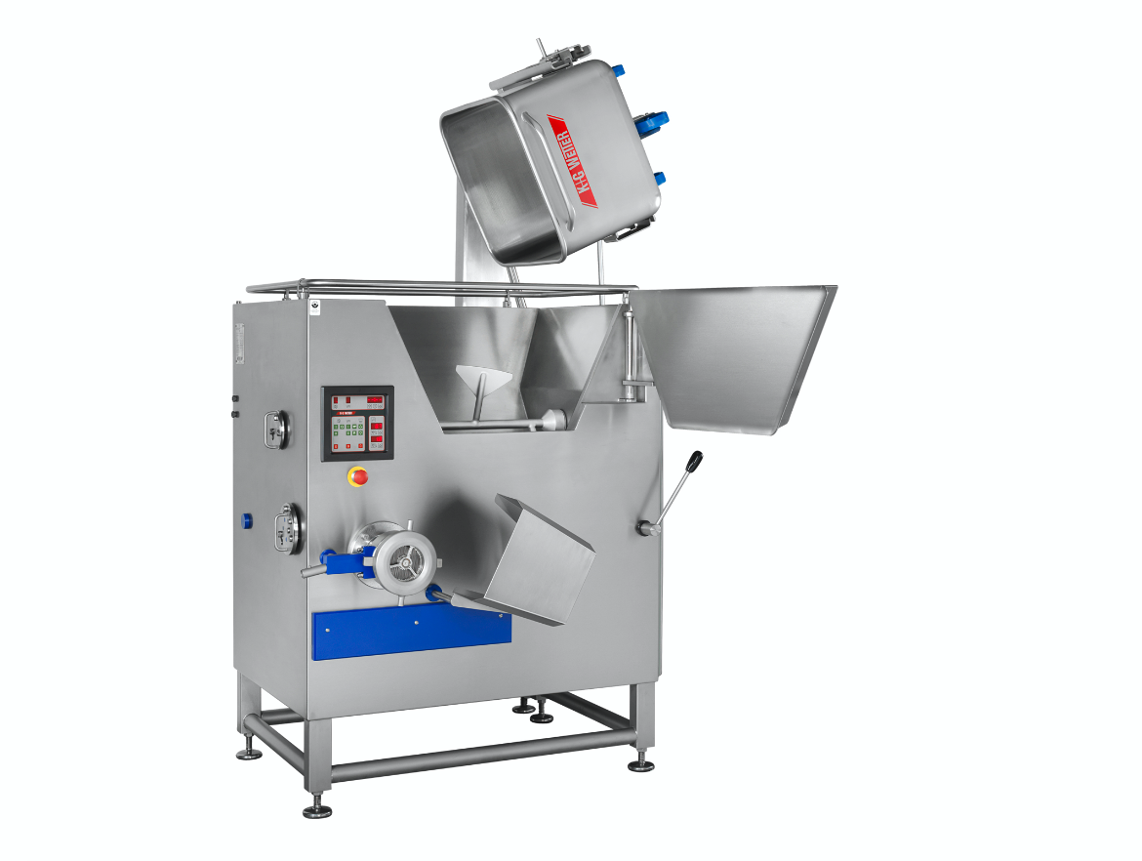
© K+G Wetter
Caption: A clear advantage in terms of hygiene: the generous "Easy Access" opening allows direct access to the hopper, which, in addition to the work at hand, also makes cleaning much easier.

Press photo 2:
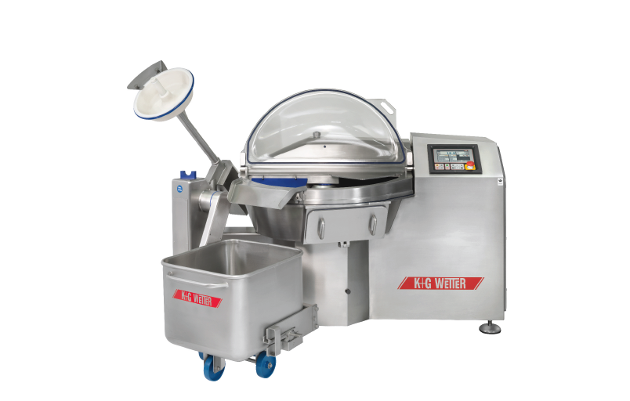
© K+G Wetter
Caption: Clever in detail: The divided lid of the VCM 120 by K+G Wetter facilitates access to the bowl and makes loading and unloading the bowl cutter significantly easier and faster.

Press photo 3:
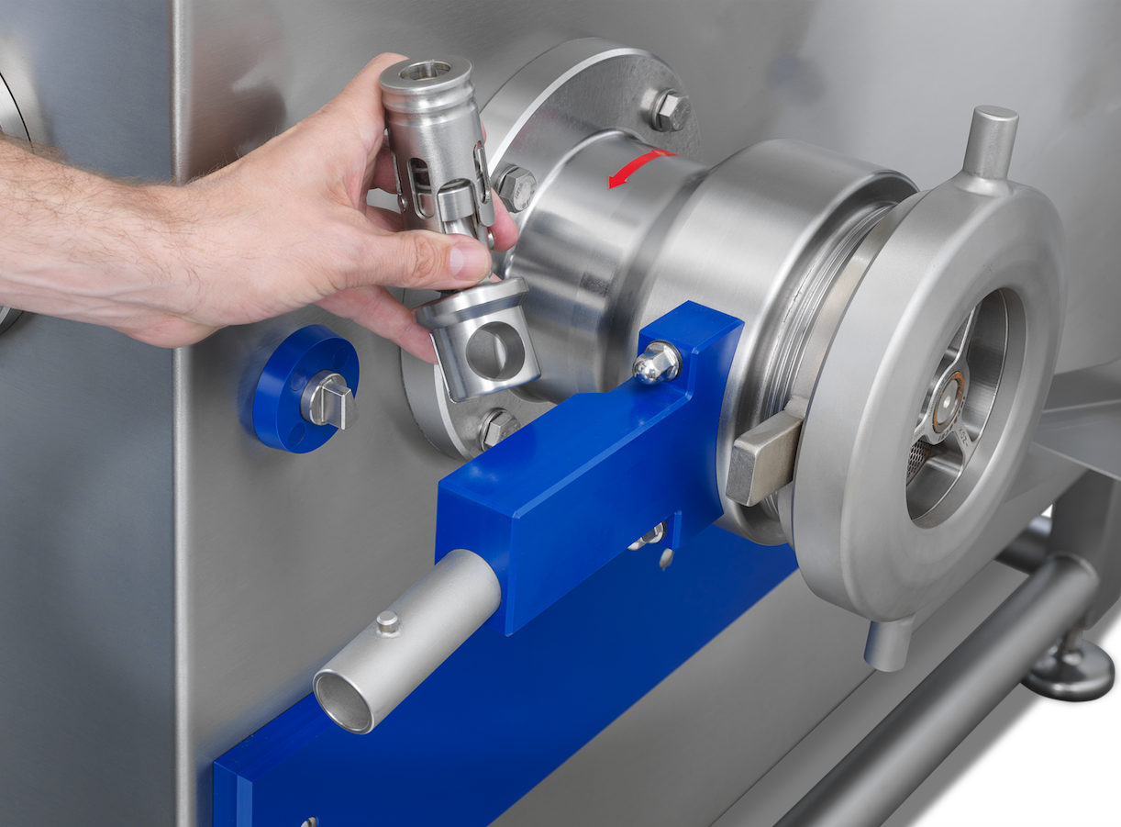
© K+G Wetter
Caption: The connection of the drive to the closing mechanism of the K+G Wetter sorting device can be easily and effortlessly separated via a plug connection, ensuring efficient processes and the thorough cleaning of the individual components.

Contact details:
K+G WETTER GMBH
Goldbergstrasse 21
35216 Biedenkopf-Breidenstein
www.kgwetter.de

Your personal contact:
Yvonne Scheurer
PR/Media
T. +49 (0) 2 71 . 77 00 16 - 26
F. +49 (0) 2 71 . 77 00 16 - 29
y.scheurer@psv-marketing.de
www.psv-marketing.de

