PRESS RELEASE
K+G Wetter GmbH
09/03/2016

K+G Wetter: New 120-Litre Vacuum Cutter
Two-section vacuum lid allows very rapid loading and emptying

Vacuum cutters are the ideal solution for any area of sausage production where there is a need for better processing of the meat, longer shelf life and firmer and more compact sausages. At this year's IFFA, K+G Wetter is presenting a new 120-litre Vacuum Cutter (VCM 120). One essential feature of this is the two-section vacuum lid. This technical solution means that instead of raising the entire vacuum lid, merely the front part needs to be raised. In this way the operator gains access to the cutter bowl easily and significantly faster. The aim of the designers was to develop a solution for the lid which made it possible to load and empty the cutter just as quickly as with an open cutter without vacuum technology. This means that production times can be significantly reduced.

This smart solution for the lid is built into the vacuum cutter of the Cutmix range with a capacity of 120 litres. This range has a smaller vacuum space, which means that valuable time is saved in the production process. The cutter is designed primarily for butcher's shops and small industrial companies.

New touch panel
This long-established company from Hesse has developed a touch panel for its trade cutter range. It is intuitive to operate and the overview of the functions is ideal – which is a great advantage for training employees to use the machine. The new operating panel can also be configured to suit individual customer-specific needs. The standard version of the touch panel has digital displays for knife shaft speed, temperature measurement, and bowl revolution with controllable immediate automatic cut-out functions. For all its cutters in the Cutmix range K+G Wetter offers the option of the software solutions CutVision and CutControl for recipe management and quality management; these are also operated via the panel.

Clean and compact solutions
The new vacuum cutter has extensive access for cleaning. It is also easy to clean underneath the bowl, which takes a great deal of time in the case of numerous other machines. There is plenty of space and all areas of the cutter are easily visible to allow cleaning to be checked visually. Water and detergents can be used in specific areas – also underneath the cutter bowl. K+G Wetter has made sure that the new 120-litre Vacuum Cutter is built in a very compact way in order to provide room in a limited space.

Options: integrated cooking system and further details
The Vacuum Cutter will also have the option of a cooking system, which is integrated in a double-walled cutting bowl, leading to a marked improvement in terms of hygiene. The bowl has a raised edge, which stops the sausage mixture spilling over and thus prevents any loss of the product. The work space therefore stays considerably cleaner during the processing procedure. The bowl drive is variable, with six different memory settings to input the speed of rotation. In addition there are six memory settings for adjusting the knife shaft and two memory settings to vary the mixing speed.

The massive machine stand made of grey cast iron absorbs any vibration very effectively and ensures that the Cutmix range machines run quietly, with good sound insulation and are extremely stable, thus also ensuring a long service life for the machines. The knife cover has a removable wall so that the cutting area can be adjusted according to the sausage being processed. An electric knife shaft brake protects the motor and the machine’s support.

You can access further information on the new innovations and the whole range of machines produced by K+G Wetter at the IFFA, Hall 8, Stand B 68, or on our website: www.kgwetter.de.

K+G WETTER GmbH
K+G Wetter is a global partner of choice when it comes to manufacturing high-quality, reliable meat-processing machinery. K+G Wetter develops innovative bowl cutters, meat grinders and mixers for butchers and skilled operators engaged in the meat-processing trade. The sophisticated technology and high-quality processing features of K+G Wetter machines play a significant role in bringing about customers’ corporate success. An internationally renowned brand, this company from Biedenkopf-Breidenstein in Hesse (Germany) supports its customers by dispensing personalised and individual advice.
www.kgwetter.de

Press photo 1:
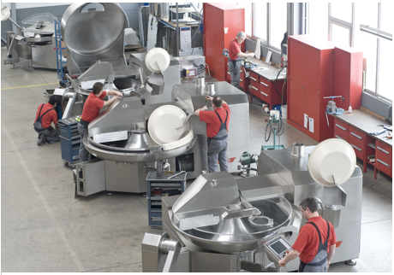
© K+G Wetter
Photo subtitle: The team at K+G Wetter works actively to find new solutions for meat processing in trade and industry.

Press photo 2:
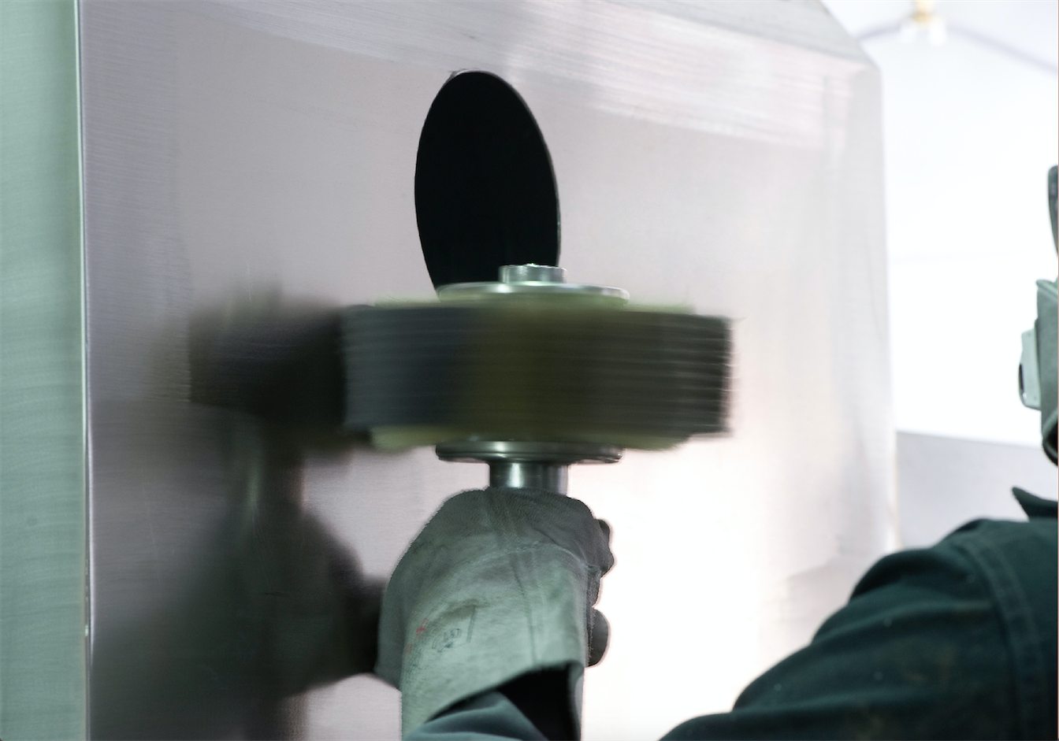
© K+G Wetter
Photo subtitle: The machines of K+G Wetter are polished by hand to ensure they make a brilliant impression at IFFA 2016.

Contact details:
K+G WETTER GmbH
Goldbergstrasse 21
35216 Biedenkopf-Breidenstein
www.kgwetter.de

Your personal contact:
Yvonne Cron
PR/Media
T. +49 (0) 2 71 . 77 00 16 - 26
F. +49 (0) 2 71 . 77 00 16 - 29
y.cron@psv-marketing.de
www.psv-marketing.de

