PRESS RELEASE / USER REPORT

K+G Wetter GmbH
July 2024

The CM 70 from master butcher Landes: Sought and found
Cutter from K+G Wetter is a well-considered choice

In a traditional butcher's shop, a new cutter is much more than a machine made of metal, motors and knives. ‘You enter into a bond with the machine,’ Thomas Landes admits. The master butcher was therefore meticulous in his research when it came to replacing the 40-year-old cutter in the family business in Denkendorf, Bavaria. After discussions with colleagues and various visits to manufacturers, the machine of choice was the CM 70 cutter from K+G Wetter with the CutControl recipe management software.

Hand-crafted cutter for boiled sausage specialties
The CM 70 from K+G Wetter has a central place in the Landes sausage kitchen, which is located directly behind the butcher's shop on the main street in Denkendorf. The compact cutter is a centerpiece of Landes' hand-crafted sausage production, as the various boiled sausage specialties are an essential part of the extensive sales counter. Four employees are responsible for preparing the meat delivered by local farmers for sausage production and sale in the shop.

A convincing performance
‘We didn't leave anything to chance,’ says Thomas Landes, recalling the search for the cutter that would accompany him in sausage production for decades to come. ‘We took a close look at all the manufacturers that we considered to be the leaders in the field. In the end, it wasn't the purchase price that was decisive, but the individual points that we evaluated. What do a few thousand euros matter when you know that the cutter will earn money for at least a generation?‘
’We were on site everywhere first, that is, in the machine manufacturers’ factory.’ In addition, Thomas Landes talked to fellow butchers about their experiences and watched various machines in action there. ‘We felt comfortable with K+G Wetter from the very beginning, that's for sure,’ recalls Thomas Landes. “We made an appointment and were allowed to look at everything. I have a lot of respect for that, and they really look after their employees.” Another plus point: K+G Wetter has a very high level of vertical integration and manufactures a great deal of its own products. An invaluable quality advantage.

A long search – ready to go in a flash
The decision-making process for the new cutter at Landes was as detailed as the machine was ready to go and the first sausage meat produced in a flash: ‘If you've never seen it like that, it's exciting,’ says Thomas Landes. ‘We set up the cutter, laid the cable down into the basement, the electrician connected everything and an hour after delivery we were making sausage.’ This is made possible by the unique compact design of the K+G Wetter cutter: everything is already integrated into the machine body, which saves a separate control cabinet with complex external cabling. ‘Otherwise, you have to expect additional time for installation,’ says Ralf Klein, the regional sales manager of K+G Wetter, who is responsible for the Landes butcher's shop.

Practical details make work easier
The machine has been in use at Landes' sausage production facility since October 2023. Thomas Landes is currently fetching the prepared ingredients from the cold store: the production plan includes basic sausage meat, which is made from meat, bacon, ice and spices and forms the basis for various types of boiled sausage. To fill the machine, employee Georgios Theodoru opens the cutter's lid electrically at the push of a button. A feature that saves a lot of lifting work day after day. ‘We've only seen this on a cutter of this size at K+G Wetter,’ says Thomas Landes, pleased with the labour-saving feature.

CutControl for reliable quality and time savings
As an experienced master butcher, Thomas Landes naturally has the preparation of traditional sausage specialties in mind. Nevertheless, the recipe management software CutControl from K+G Wetter played a crucial role in the choice of the new cutter: ‘Nobody can do this like K+G Wetter,’ says butcher Landes. The principle: recipes are stored in detail in CutControl, displayed directly on the large and clear touch display on the cutter and processed step by step. In addition, the program takes over the exact conversion of the ingredient quantities for each batch size. ‘CutControl is a decisive advantage for me because you can rely on it completely, for example that the temperatures are not exceeded. The blade speeds are always exactly the same.’ The result is exactly reproducible quality: ’If the basic material is right, the outcome is always the same good product. And to be honest, you wouldn't even bother to set the speeds as precisely as the programme does every time. I think that's great, and you can be sure that the employee will do it the same way.’

Thanks to CutControl, a large number of recipes can be stored and reliably prepared – a major contribution to quality assurance and the preservation of traditional butcher's knowledge. Thomas Landes has also saved various pure mixing programmes, for example for coarse bratwurst. In a series of precisely defined steps, the cutter ensures that the meat, spices and various ingredients are always perfectly mixed. Thanks to the automatic switch-off function, which can be set to a freely definable speed, time or temperature, overmixing is ruled out. ‘You can also do other things without having to worry about anything going wrong, the material getting too warm or anything else. You can go down to the cellar and get a packet of spices that you still need. Because you can be sure that it will work out,’ says Thomas Landes. Working time that saves significant amounts of time every day, step by step.

Clever operating details, the finest sausage meat, little noise
The meat is in, Thomas Landes closes the lid and starts the first programme step. The first cutting step is completed in no time at all, and the sausage meat is already evenly fine. This is made possible by the baffle plate in the CM 70 from K+G Wetter: when it is used, the cutting chamber is smaller, and the sausage meat is cut particularly quickly and intensively. Thomas Landes: ‘This was not available from other manufacturers, which is why they did not achieve this fineness of the sausage meat in such a short time. The baffle plate is a huge advantage.’ The Landes butchery has relied on the sharpening service from K+G Wetter from the very beginning to ensure that its knives are always sharp. ‘I wouldn't let anyone else touch them. I feel safe when I send them in.’ The touch display even explains how to change the knife head step by step with clear pictures: ‘It's really a great solution and it's fun. You can just see how it works,’ says Thomas Landes.

The master butcher works through the basic sausage meat recipe, adding spices, bacon and ice, and then starts the next processing step. Incidentally, all he must do is close the noise protection lid without having to use the touchpad. ‘As a butcher, you always have your hands full, but with CutControl, that's no longer an issue because you jump to the next step by lifting the lid. You don't even need the touch panel,’ says Thomas Landes, describing his experiences.

Another well-thought-out detail becomes apparent when all the ingredients are in the bowl and the sausage meat is going through the last processing step: the raised cutter bowl rim ensures that the sausage meat stays in the bowl even when it is at its maximum level – this prevents product loss due to overflow and is of course much more hygienic.

The fact that you can still talk to each other while the cutter does it’s work is another advantage of the CM 70, which the staff appreciate just as much as the hotel guests at Landes: thanks to the cast iron machine stand, which is exclusive to K+G Wetter cutters, the CM 70 runs extremely smooth. ‘This cutter was by far the quietest,’ says Thomas Landes, recalling his comparisons before the purchase. ‘This fascinated us from the outset and is enormously important for the employees, but also for the hotel guests who live in the rooms above the butcher's shop."

A thrifty machine
The CM 70 is not stingy with quality, hygiene and durability, but the compact craft machine is extremely modest when it comes to energy consumption: ’Other machines of the same size have a motor that is twice as powerful. And has a correspondingly high power consumption. That is a very important issue,’ emphasizes Thomas Landes. “You always need more and more electricity anyway. So, you are happy about every kilowatt saved, also because everything needs adequate fuse.”

Lasting values
The K+G Wetter CM 70 cutter has been in service in the Landes sausage kitchen since October 2023 – and will probably continue to do so for decades to come. And if the machine does have to make way for a successor at some point, it has another trump card up its sleeve: ‘The resale value of K+G Wetter machines is enormous,’ says Thomas Landes with a smile. Until then, the cutter will continue to provide generations of Denkendorf residents and guests with delicious cold cuts, traditional Leberkäs and crispy sausages – in a quality that is really tasty bite after bite.

The Landes Butcher's
The Landes family is now in its third generation of running the Gasthof zur Post in the Bavarian town of Denkendorf in the Altmühltal valley north of Ingolstadt. The butcher's business has been complementing the traditional restaurant and hotel business with its associated farming since 1981. Hotel guests enjoy the sausage specialties at breakfast, as do customers from Denkendorf and the surrounding area. And travellers and tradesmen enjoy a quick snack of regional specialties from the butcher's counter during their break.

Metzgerei Landes

K+G Wetter

Photos: K+G Wetter

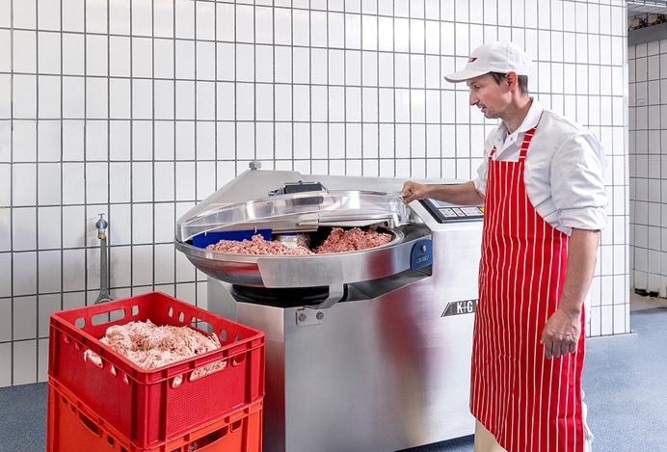
Caption: By opening and closing the noise protection lid, Thomas Landes controls the processing steps in the preparation of the basic sausage meat.

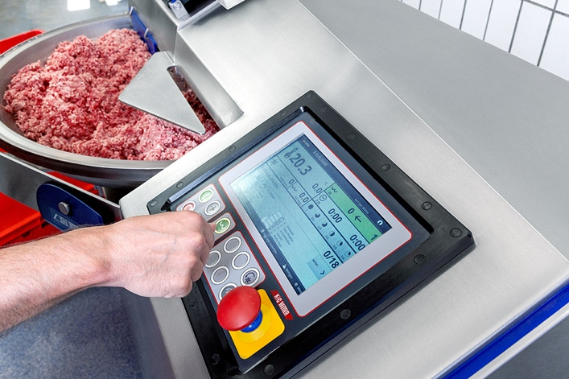
Caption: The preparation of Landes specialties is precisely stored step by step in the CutControl recipe management system – for reliably top quality.

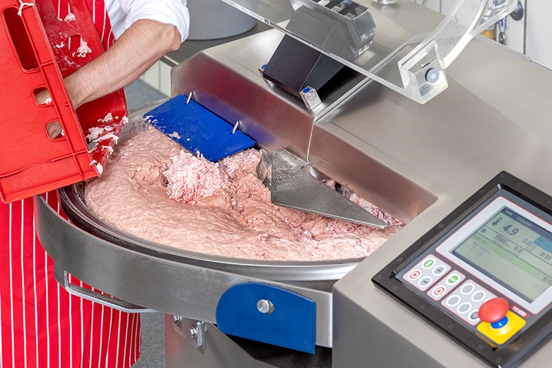
Caption: The raised bowl rim on K+G Wetter cutters such as the CM 70 reliably protects against product loss even at maximum filling height.

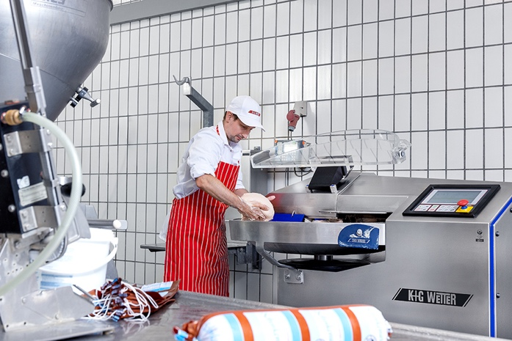
Caption: Thanks to the baffle plate, the sausage meat is cut particularly quickly in the reduced cutting chamber, perfectly bound and ready for filling.

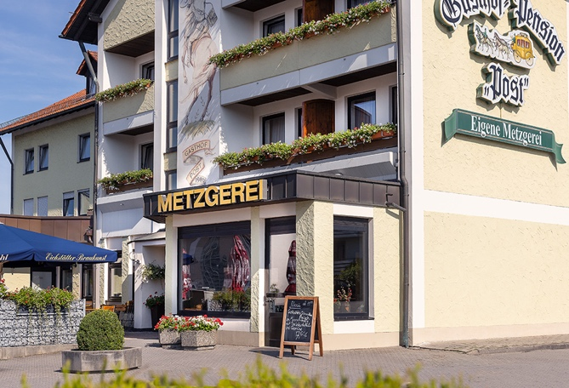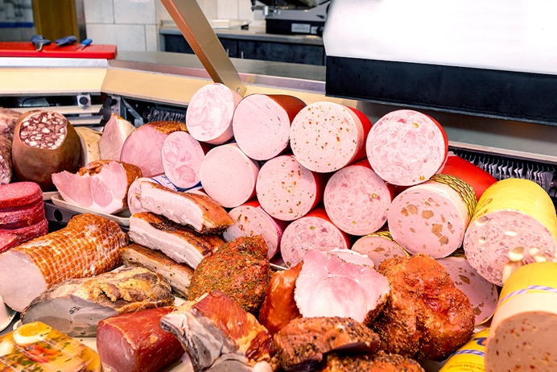

Caption: At the Gasthof-Pension Post, which has its own butcher's shop, the people of Denkendorf and guests from near and far enjoy fresh sausage specialties from the production of Thomas Landes with the cutter from K+G Wetter.

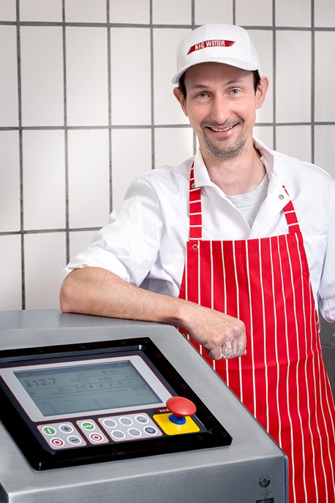
Caption: Master butcher Thomas Landes with his CM 70 from K+G Wetter

