Trade vacuum bowl cutter VCM 70 rounds off Hygienic Secure range

K+G Wetter rounds off its Hygienic Secure range with the VCM 70 vacuum bowl cutter sized for trade applications. This compact machine shines with award-winning and patented hygiene features that have won over customers for years when fitted to the company’s larger industrial bowl cutters.
The new VCM 70 features large cleaning flaps inside the vacuum vessel. This also makes the area beneath the cutter bowl very easy to view and offers optimal accessibility for cleaning. None of the vacuum bowl cutters in the Hygienic Secure range have a seal between the cutter bowl and vacuum vessel, thanks to the machines’ special design. K+G Wetter has therefore eliminated one of the most critical points from a hygiene perspective, because product residues are unable to adhere when there is no seal. This means that there are no concealed cavities where germs can develop.
Being a Hygienic Secure bowl cutter, the VCM 70 also features the patented removable knife cover strip, which won the Silver FoodTec Award in 2021. The knife cover strip can be removed and reinserted for cleaning in one easy step, thereby eliminating a further extremely hygiene-critical area. Moreover, the special design also allows the knife cover strip to move vertically, reducing both abrasion and the braking effect on the bowl.
The controller and maintenance-free water ring pump are directly incorporated into the VCM 70. The benefit here is that additional externally routed and hygienically critical cables and lines are rendered superfluous. In addition, the cutter is of very compact design.
From a technical perspective, the vacuum bowl cutter facilitates and supports daily operations in the butchery with well thought-out features: The blade and bowl speeds can be ideally adjusted to suit the respective product thanks to the stepless drive (STL). The VCM 70 can be operated intuitively via a touch panel. This panel also allows the vacuum level to be easily set and the machine always maintains a constant fill level. In this way, the benefits of production under vacuum come into their own, meaning that butchers and manufacturers of vegetarian and vegan products can rely on consistent quality at all times.
Using the trade bowl cutter is made even easier when using the Cut Control recipe management system: The software stores the recipes for butchers’ craft specialities and guides the operator step by step through the production process. At the same time, shutdown functions such as temperature, time and bowl revolutions are defined for each production step – delivering reliably high product quality.
www.kgwetter.de
Image caption: The compact VCM 70 Hygienic Secure vacuum bowl cutter sized for trade applications shines with award-winning and patented hygiene features that have won over customers for years when fitted to the company’s larger industrial bowl cutters.

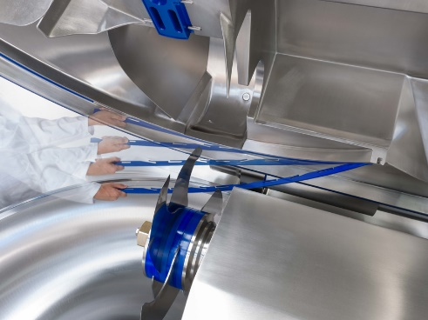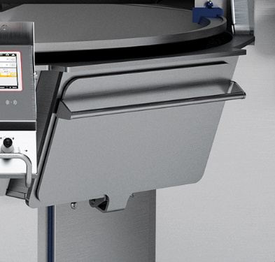
Image caption: A hygienic highlight that is unique worldwide for the Hygienic Secure vacuum cutters of K+G Wetter is the patented knife cover strip. To clean, it can be simply clipped on and unclipped without tools. Easily accessible cleaning flaps enable simple and safe cleaning. All this saves time and money and ensures products of the highest hygienic quality.

