Hearty classics reinterpreted in vegan form by Tressbrüder
Vegetarian dishes are created in the Hygienic Secure vacuum bowl cutter from K+G Wetter

Currywurst, meatballs and burgers, doner kebabs, chicken curry and goulash – are we discussing the lunch menu at the butcher’s shop or fast-food restaurant around the corner? It’s actually an excerpt from the product range offered by Tress Lebensmittel GmbH & Co. KG. Since autumn 2022, the traditional company in Zwiefalten in the Swabian Alb has produced organic ready meals using predominantly regional ingredients – and they are completely vegan. The VCM 120 Hygienic Secure vacuum cutter from K+G Wetter is used in the production of these meals and is responsible for processing the vegetable proteins.

Tress has set up production of its ready meal product line under the “Tressbrüder” brand in an industrial estate above the pretty village located on the Upper Swabian Baroque Route. From the former premises of a forwarding agency there is an all-round view over farm fields and meadows. The aroma of spices fills the air inside: plenty of curry, various herbs, a hint of chilli.

Benjamin Bross is responsible for production here. The 33-year-old is a trained butcher and he moved to Tressbrüder in 2022 after 16 years at a local butcher’s shop. “I had an urge to learn something completely new again,” he explains. “So new, in fact, that I don’t actually have a job title yet! Production manager, product developer, process developer; my tasks here are many and varied,” says Bross. In fact, he helped set up the production line from delivery of the very first machine – storage, peeling and cutting machines, boiling pans, refrigeration – and a bowl cutter.

The vacuum bowl cutter from K+G Wetter was his express wish for the production line. “We previously enjoyed excellent cooperation with K+G Wetter in the butchery before, and I am well aware of the machine’s capabilities. It’s highly versatile, for example because of the removable baffle plate. “The advantage this offers is that it downsizes the cutting chamber, which is beneficial for achieving a high knife shear force and emulsification.
Without a baffle plate, on the other hand, the entire cutting chamber beneath the knife cover is used without any limitations. The material being processed then passes through the cutter head with very little friction. As a result, the cutting pattern is clearer and the temperature does not rise as much.

The bowl cutter is equipped with the CutControl recipe management software. So far, over 40 Tressbrüder recipes have already been stored, but many more product developments are still to come. In due course, these will also be transferred from Benjamin Bross’ office to the cutter via the company’s network.

One very important aspect is that CutControl does not limit the number of programme steps that can be stored. “I can save my recipes in great detail, even though some of them have over 20 steps. This makes life easier for the production staff,” says Benjamin Bross. It even transcends language barriers: Benjamin Bross speaks English with Aurelian-Denis Cocan, who is currently working on the production of the vegan mini-meatballs for the snack range. But English isn’t the mother tongue of either man. “It presents a minor hurdle,” says the production manager. “But with CutControl, anyone can operate the machine – following a brief introduction to the technology and raw materials.”
A positive side effect is that the clear textual instructions on the large, intuitive display prompt staff to learn the technical terms in the chosen language in no time.

Thanks to the program control, the machine automatically takes care of processing times, bowl revolutions, vacuum level, the required amount of water to be dosed, and the knife speeds for every stage of the recipe. Moreover, it also monitors the product for preset shut-off parameters. Aside from the temperature, these may also include the number of bowl revolutions or the processing time. For example, once a pre-programmed temperature is reached, the bowl cutter may either switch off or continue to the next programme step. “The temperature is measured inside the cutting chamber, i.e. where it heats up the fastest,” reports Benjamin Bross. That makes the measurement particularly accurate.

The Tressbrüder fast food dishes that end up on a plate as mini meatballs, curry sausage, minced meat or juicy pieces of goulash are created in the bowl cutter using regional raw materials. These are mainly soy from the Lake Constance region, together with proteins from lupins, sunflower seeds or linseed. In the “vegan butchery”, the working title for the new Tress production line, Aurelian-Denis Cocan is just starting to prepare a batch of vegan meatballs. The basic ingredient is textured soy protein (TSP): dry flakes of vegetable protein a few millimetres in size.

To prepare something that feels and tastes like meat on the palate, the first processing step is to add water. Thanks to fully automatic water dosing, another special feature of K+G Wetter’s VCM 120, the right amount of water flows directly in front of the knives into the cutting chamber when the program starts. “We had a cold and a hot water line installed which also allows us to adjust the temperature to suit the product being processed,” says Benjamin Bross. Vegetable oil is added next, followed by various spices and beetroot juice to give the meaty red colour. After all, it must also be pleasing to the eye. Once the textured soy protein has been added, the machine also performs the next processing steps automatically, including briefly applying a vacuum twice. When Cocun opens the noise protection lid, the soy, liquids and spices have completely combined. According to Benjamin Bross, “The vacuum ensures that the pieces soak up liquids perfectly and uniformly”. The vegan mass bears a strong resemblance to sausage meat. To achieve the desired graininess to give meatballs their bite, additional proteins are now chopped in to achieve perfect binding and consistency.

Each work step is started by opening or closing the noise protection lid. “It’s practical and saves a lot of time – we don't even need to access the touch panel anymore,” says Benjamin Bross. During the product development phase, Benjamin Bross and his team performed detailed tests to find out the number of revolutions the bowl has to make to achieve the perfect vegan burger mixture and how fast the knives need to rotate. This information is then saved in CutControl. The baffle for reducing the cutting chamber size is not fitted this time, so the cutting pattern of the rather coarse-grained mixture is clearer.

What type of vegan protein forms the desired gels at what temperature? What other ingredients are needed to achieve the perfect taste and in which quantities? How long do the purely vegetarian meatballs or sausages need to mature until they are ready for final processing? Benjamin Bross has worked out all this in detail himself. What emerges is very close to grandma’s traditional fare – it’s cooked with experience, knowledge of correct food preparation... and patience. The knowledge the trained and experienced butcher has gained regarding vegan proteins is so detailed that Tressbrüder production has already been in contact with research and development institutes.

The objective is for Tressbrüder products not to contain any additives such as emulsifiers or phosphates. “Armed with the right knowledge and sufficient time for processing, we can easily dispense with chemical additives,” explains the butcher. “Meat already contains protein, fat and water, so a bond is created during processing. However, vegan proteins are far more difficult to process into an emulsion.” This is where the vacuum function of the VCM 120 comes into play: Interval vacuum generation and corresponding evacuation are used to knead the ingredients intensively. This is the only way to achieve a bond. At the same time, the vacuum draws trapped air out of the product, thereby preventing an undesired sponge-like structure.

The bowl cutter in the Tressbrüder production hall is empty and the mixture is on its way to the next machine, which will turn it into small burgers. When it comes to cleaning, the VCM 120 type 506 was the first machine in K+G Wetter’s Hygienic Secure range. Its hygiene features received the FoodTec Award 2021, among others. Accordingly, the vacuum bowl cutter is easily and quickly cleaned and ready to process the next product. Aurelian-Denis Cocan opens the lid of the machine completely and rinses everything with hot water. The hand-polished and fully bevelled surfaces mean that the cleaning liquid runs off without ponding, taking product residues with it. The water runs out of the cutter bowl through the water drain into the vacuum vessel, from where it exits via large cleaning flaps. These two flaps, which can be opened without tools, enable Tressbrüder staff to easily clean the underside of the bowl as well as the vacuum chamber – with hygienically reliable access right into the last corner. The large size of the cleaning flaps also allows the result of cleaning to be easily checked.

A unique selling point that offers an incomparable hygienic benefit in terms of cleaning is that a seal is no longer fitted between the cutter bowl and the vacuum vessel. This area – where a seal is traditionally found and which is otherwise impossible to clean reliably – can now be rinsed out quite simply using a cleaning lance, spray head or water hose. “Cleaning is performed by our staff, each worker cleaning his own machine. He therefore knows which corners require particular attention,” adds Benjamin Bross.

It is also possible to clean other sensitive areas perfectly. For example, the bowl support pad, the bowl scraper and even the patented knife cover strip can all be removed from the cutter in one simple action. Hygienic solutions that guarantee safe products.

The VCM 120 is rapidly ready for use again: This time, vegan mayonnaise is on the menu, made from vegetable oil, water, vinegar, spices and other ingredients. Animal products are banished here too. “For the mayo we reinsert the baffle plate; shear forces and friction on the blades are important in this application to allow the ingredients to combine well.”

What do you use to combine oil and water to form the emulsion, when you can’t use an egg yolk as normal? “That’s a trade secret,” exclaims Benjamin Bross with a smile. The finished mayonnaise, which is used in Tressbrüder products – to make their vegan salads for example – is discharged via the unloader into waiting batch trolleys after completion. Immediately after preparation, the mass is still quite liquid, but the shape and orientation of the unloader ensure that the cutter bowl is emptied quickly and completely.

Incidentally, another reason the company invested in the K+G Wetter vacuum bowl cutter was Benjamin Bross’ experience with the service provided by the company from Biedenkopf-Breidenstein in the German State of Hesse. “In the past, we already gained a good impression of the service provided by K+G Wetter in the butchery,” recalls the Tressbrüder production manager. “Whenever a service call became necessary, the response was super fast.”

The Tressbrüder brand’s organic vegan ready meals are shipped from the company’s premises in Zwiefalten to large food retailers and specialist organic stores. Customers are also able to select tasting packages and favourite dishes for a quick lunch break or snack via an online shop and have them sent to their homes. But Tress employee’s aren’t bound to live a vegan life themselves. “I still like eating meat,” confesses butcher Benjamin Bross, “I don’t consider our vegan dishes as a substitute for meat, but as products in their own right. They are really very similar to meat dishes in terms of taste and consistency – and also have traditional names – this naturally makes it easier for customers to just give them a try.”

The way the Tress brothers’ business has grown shows that the company’s products cater to their customers’ taste. Currently they are still operating a single-shift, but the company is aiming for two shifts by 2024. And there is still room to expand the production line on the current premises. Vegan spreads are currently new in the range, and other products are under development. So there are many possible ways to apply Benjamin Bross’ team’s creativity – and the vacuum bowl cutter from K+G Wetter. This is how sophisticated technology is used to turn fresh, regional organic products into vegan foods that delight customers.

The Tressbrüder brand

The Tress family business dates back to 1950. Grandfather Johannes Tress was the first farmer in the area to convert his farm to biodynamic agriculture in accordance with Demeter standards. Son Johannes and wife Inge shaped the business in the 1980s by, among others, serving up sustainable vegetarian whole food cuisine in the “Rose” inn. Since 2008, the four Tress brothers Daniel, Christian, top organic chef Simon and Dominik have been running the family business with around 80 employees in various roles.
The Tressbrüder world: tressbrueder.de
Bowl cutters, grinders and mixers for food processing applications: kgwetter.de

Press images: K+G Wetter

IMG_0464: In the Swabian Alb town of Zwiefalten, Tress Lebensmittel GmbH & Co. KG produces organic ready meals with purely vegetable ingredients under the Tressbrüder label.

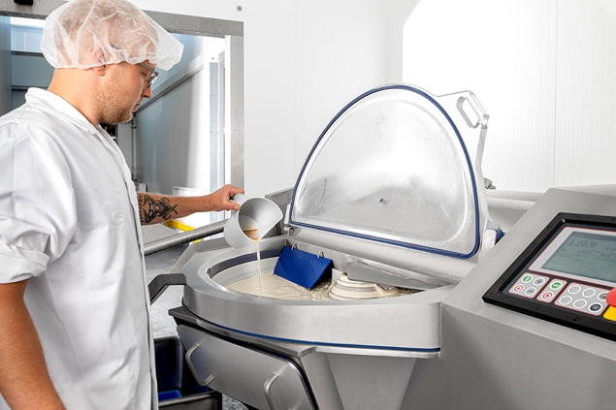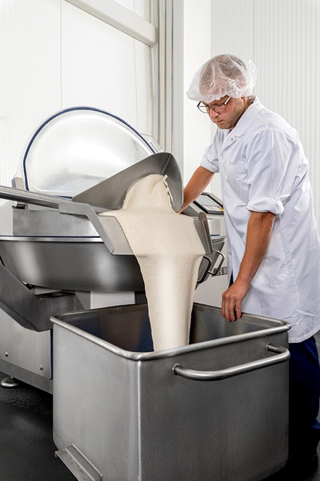

IMG_563 and _573: Production manager Benjamin Bross prepares vegan mayonnaise using the VCM 120 from K+G Wetter. The ingredients and quantities can be read on the touch display thanks to the CutControl recipe management software. The next processing step is started automatically with a click or by closing the noise protection lid.

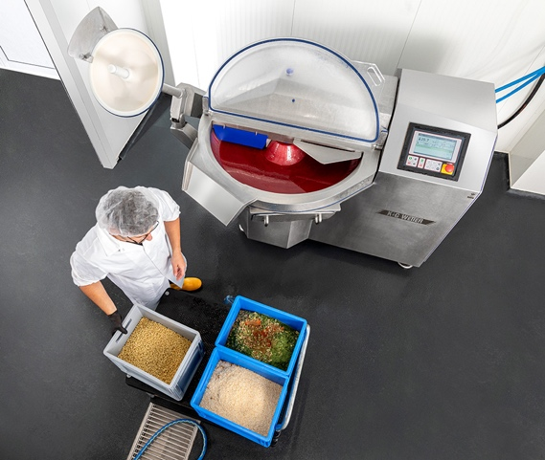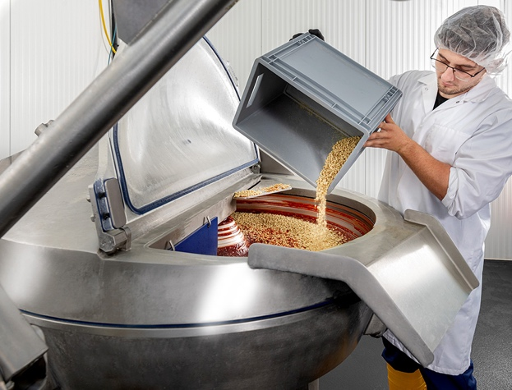

IMG_617 and _631: Here, Tressbrüder employee Aurelian-Denis Cocan prepares the mixture for the vegan mini meatballs. The vacuum function of the cutter ensures that the ingredients are perfectly combined.

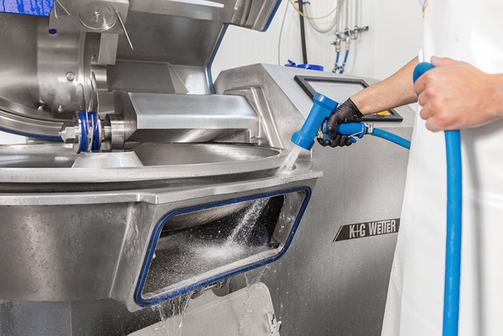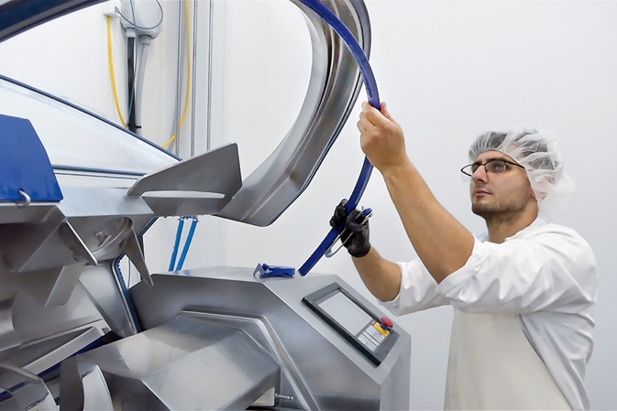
IMG_700 and _Cleaning: The VCM 120 Hygienic Secure is optimised for exceptionally fast and hygienic cleaning – thanks to its large cleaning flaps and a patented knife cover strip, for example. And the best seal? It’s the one you don't need: The VCM 120 does not need a seal between the vacuum vessel and the cutter bowl.

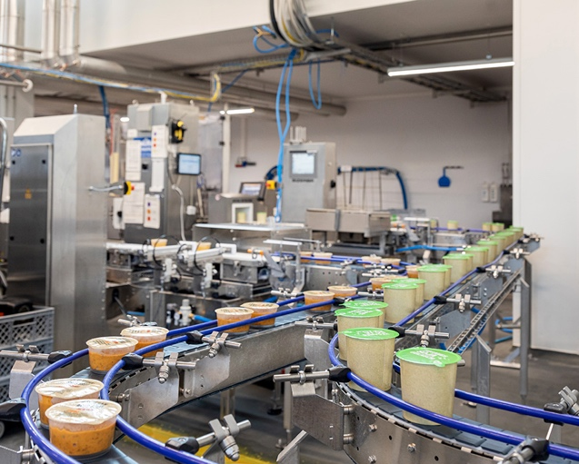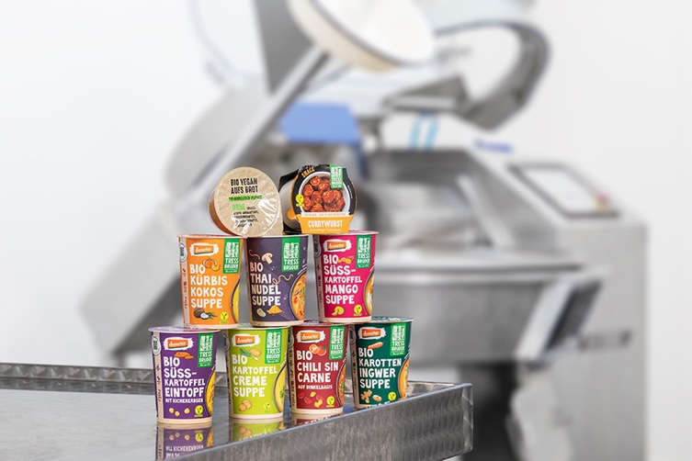

IMG_734 and _767: The fresh, vegan snacks, soups, stews and ready meals from Tressbrüder can be quickly prepared during lunch break. Sustainably packaged in portions, the organic ready meals are available from the online shop or retail outlets.

