Tradition, technology, appreciation of trends
Butcher World Champion Matthias Endraß relies on bowl cutters and grinders from K+G Wetter

How did the Endraß butcher’s shop, situated in the Bavarian village of Bad Hindelang, literally take the World Champion title in just a few years? With entrepreneurial vision and an appreciation of trends combined with the right mixture of tradition and technology: artisanal techniques such as butchering and cutting with the cutting edge machine technology inside K+G Wetter’s bowl cutters and grinders. The bowl cutter is equipped with the CutControl software. This allows the butchery to manage the recipes and control the production steps throughout the cutting process.

At 35 years of age, master butcher Matthias Endraß, together with his sister Ina, is the fourth generation to run the family business, which will celebrate its hundredth anniversary in 2025. “In 2016, we decided to refocus the butchery,” explains Matthias Endraß. To enable them to learn new and modern meat processing methods, the siblings decided at the time to undergo additional training to attain the level of meat sommelier. Their objective was to combine current trends with tried-and-tested favourite products in order to gain new customers. “It was the right idea at the right time and made such a big impact.” Contemporary cuts, preparation, presentation – the already experienced meat experts had plenty of new techniques to learn. “I learned an incredible amount. Even things I had learned up to that point were often already out of fashion,” remembers Matthias Endraß. “The course enabled us to think outside of the box.” Word quickly spread among customers from near and far that the small butcher’s shop with a panoramic view of snow-covered Alpine peaks offers not only traditional specialities such as Landjäger sausage, white sausage or roasts – but also trendy steak cuts and dry-aged beef. The siblings succeeded in moving up from a regional supplier to an insider tip for visitors from afar. The provisional highlight in the history of the butcher’s shop is that Matthias Endraß and five colleagues in the “Butcher Wolfpack” as Team Germany were crowned winners of the World Butchers’ Challenge 2022 in Sacramento (USA). Matthias’ sister Ina was the best woman at the World Butchers’ Challenge, taking fourth place in the Young Butcher category – quite an extraordinary achievement for a trained butcher’s shop assistant.

The next logical step was to upgrade the machines in the sausage kitchen at Endraß in order to meet the increased demand and larger production volume. The sausage kitchen is accessed via the rear courtyard; on the way, a sign on the wall draws attention to the World Butchers’ Challenge title. A few more steps take you into the middle of the premises where daily specialities are created for sale over the counter right next door – and, by the way, the counter is virtually the only sales channel. “We do sometimes sell to local restaurants, but otherwise everything really is sold over this one counter. That’s sufficient,” says Matthias Endraß. Tourism means that his customers now come from further afield to purchase the products that excited them on holiday.

Right now, the master butcher is at the bowl cutter, preparing fine sausage meat for the World Champion meat loaf – one of the products that won the Wolfpack team the World Butchers’ Challenge title. The CM 50 STL from K+G Wetter has been performing reliably at Endraß since January 2023, as has the MAW 114 mixer automatic grinder with sorting device. “When the machines arrived, it was like Christmas all over again,” recalls Matthias Endraß. Before the two new centrepieces of the operation arrived, a related machine had produced different types of sausage here for almost 40 years. “My father bought it from K+G (Krämer & Grebe), the predecessor company of K+G Wetter. It still ran perfectly after such a long time, so no other manufacturer came into question for me.”

After just a few weeks, World Champion Matthias Endraß has come to appreciate his CM 50 even more. The special feature of this bowl cutter for the trade is that it has an automatic recipe management system. With CutControl from K+G Wetter, recipes can be stored and called up for whatever batch size is required. Each processing step is then automatically displayed along with the ingredient, quantity, knife and bowl speed, temperature and duration. The program is started by tapping the touch panel. “If I now add the second batch of ice, it will first run on its own for six minutes,” says Matthias Endraß as he pours the required amount into the cutter bowl. “This means that for every ten batches, I have at least 60 minutes to do something else – whether clearing up, washing up or other work. These are things that are otherwise annoying and hold you up at the end of the working day.” Initially, World Champion Endraß was convinced he would not really need the recipe management software for such a small machine. “Many artisanal butchers think they don’t need it – and I thought the same in the beginning. But you have to experience it to believe it.” The difference becomes clear when a recipe has not yet been saved. “Last week we made a lot of cooked salami. I had already written the program on the PC but hadn’t yet transferred it to the bowl cutter. So I always had to wait and manually put the ingredients into the bowl. It really got on my nerves. This waiting time is simply dead time.” Matthias Endraß has already saved many of his speciality recipes using CutControl, and the number is still growing. These also include some products that are not produced using the bowl cutter – boiled ham and raw bratwurst, for example. Why? “I have everything saved in one place and all of the ingredients and quantities are displayed right in the sausage kitchen. At the same time, knowledge of the traditional family recipes and how to produce them is stored digitally. Technology and tradition complement each other perfectly here.
The CM 50 bowl cutter easily handles the rather considerable production volumes at the Endraß butchery. “We started at five in the morning, and now, at around eight, 450 kilos of World Champion meat loaf are almost ready,” explains Matthias Endraß as he starts the last processing step. Through the acrylic glass lid you can see how the sausage meat becomes finer and more uniform with each pass. The raised rim of the cutter bowl ensures that none of it escapes when the bowl volume is fully filled. Inside the cutting chamber, which is adapted to the specific product using a baffle plate, the sausage meat becomes particularly fine. CutControl automatically controls the bowl revolutions and knife speed and stops the production step as soon as the stored switch-off parameters, such as the maximum temperature, are reached. Matthias Endraß now skilfully empties the well emulsified sausage meat. “Emptying by hand is really easy here; you can reach every corner easily and there are no losses”.

Right next to the bowl cutter in the sausage kitchen stands the MAW 114 automatic mixer grinder, the second machine from K+G Wetter. “We make a lot of raw sausage, mini pepper salamis and Landjäger sausage, for example. You put the mixing paddle in, throw the spices onto the meat and press the button. Then you simply set up the syringe for filling and that’s it.” Before purchasing the mixer grinder, ground meat and spices for the raw sausage were mixed by hand, in ten-kilo batches. “Let’s not kid ourselves, after you’ve mixed 70 or 100 kilos of ground meat by hand, you aren’t going to be capable of processing the tenth batch to the same quality. At some point you’ll run out of strength,” laughs Matthias Endraß. In addition to making the work easier, the mixer automatic grinder’s new and expanded technology also saves time: “I have long been considering whether I need an automatic grinder and a mixing function. But now I’m so glad we have it – the time savings alone are worth it. For example, when I used to process bacon with the little stuffing mincer, it took me an hour to do that task alone. Now it’s a secondary task for me."
A manual sorting device in the mixer automatic grinder in the World Champion sausage kitchen ensures that unwanted hard particles in the meat, such as pieces of gristle or bone, are reliably sorted out. The fact that the machine has a lateral discharge chute is particularly efficient, because the entire cutting set cross-section is available for grinding and the area in front of the mixer grinder remains free.

At the end of a long working day, as always, the machines have to be cleaned. It needs to be fast, but at the same time safe and perfectly hygienic. The bowl cutters and grinders from K+G Wetter are also perfectly designed for this purpose; after all, hygiene is one of the core issues of the meat machinery and butchers equipment manufacturer from Biedenkopf-Breidenstein in the German State of Hesse.
“Machine cleaning is really top-notch. I think we’re three times faster than before,” says master butcher Endraß happily. “Their polished surfaces means they still look brand new each time they’re cleaned,” he enthuses. The machines, of course, don’t only sparkle superficially after cleaning: “It’s so simple to remove the meat worm, mixing shaft and cutting set, clean the parts, scrub off any residue, rinse through and that’s all there is to it.” The special hygienic feature on all K+G Wetter grinders is also used daily on the MAW 114 at Endraß: The rinsing chamber collects the smallest particles that could possibly squeeze through the meat worm seal into the inside of the machine as a result of the high pressure during mincing. “On the recommendation of K+G Wetter, we also had a water hose laid directly to the mixer grinder. This makes cleaning the rinsing chamber a matter of just a few seconds. We rinse it out every day using hot water and detergent.” For hygiene safety, this technical solution from K+G Wetter offers a real benefit. “For the sake of safety, I always used to clean the old machine using disinfectant,” recalls Matthias Endrass.

It’s now just a few steps into the shop for the finished World Champion meat loaf. Raw sausages are already hanging from the wall while Lyoner sausages, salamis, roasts and grilled meat adorn the shop’s display cabinets. In the maturing cabinet, the finest pieces are waiting to be perfectly cut by the meat sommeliers – and for customers from near and far.

The Endraß butcher’s shop in Bad Hindelang

The founder of the Endraß butcher’s shop in the idyllic spa town of Bad Hindelang was Matthias Endraß’ great-grandfather, who opened the business in 1925. Today, his grandfather is enjoying his well-deserved retirement in his childhood home. In addition to Matthias Endraß, his sister Ina, a butcher’s assistant, and the siblings’ parents also work in the shop every day.

Externally, the new modern focus of the traditional butcher’s shop is apparent in the stylised bull’s head painted in gold on the white wall of the house, which shines brightly in the sun. The modern logo also confidently adorns the Endraß professional clothing – from work aprons to baseball caps.

Thanks to their entrepreneurial spirit and appreciation of trends and technology, the traditional Endraß butcher’s shop looks confidently to the future, with 2025 set to be a benchmark year for them: There will be a huge celebration at home to mark the butchery’s 100th anniversary. Moreover, butcher World Champion Matthias Endraß and the Butcher Wolfpack, hope to defend their title at the World Butchers’ Challenge – with the right mix of trends, technology and tradition.

www.kgwetter.de

www.metzgerei-endrass.de

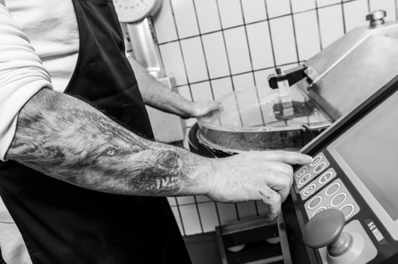
Photo: K+G Wetter (Headerphoto/Eyecatcher IMG_6898)

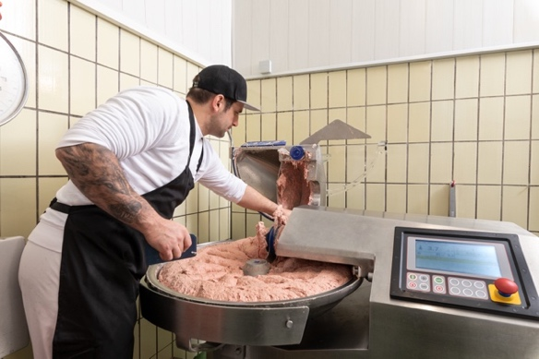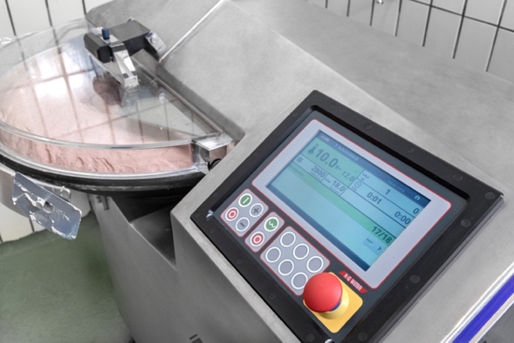
Photos: K+G Wetter (IMG_6923 and IMG_6951)
Matthias Endraß works with the CutControl software on his CM 50 bowl cutter from K+G Wetter. “You have to experience it to believe it,” says the master butcher regarding the ease of use facilitated by recipe management and production control.

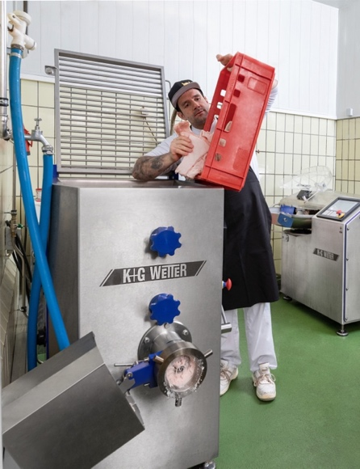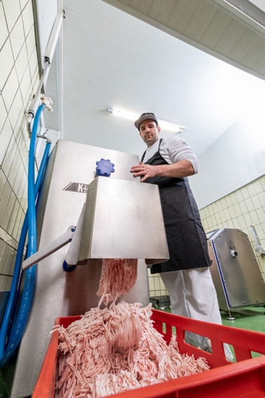
Photo: K+G Wetter (IMG_6861 and IMG_6878)
Matthias Endraß also uses the MAW 114 from K+G Wetter in his World Champion sausage kitchen. “I am so pleased that we now have an mixer automatic grinder – the time savings alone are worth it,” says the World Champion butcher.
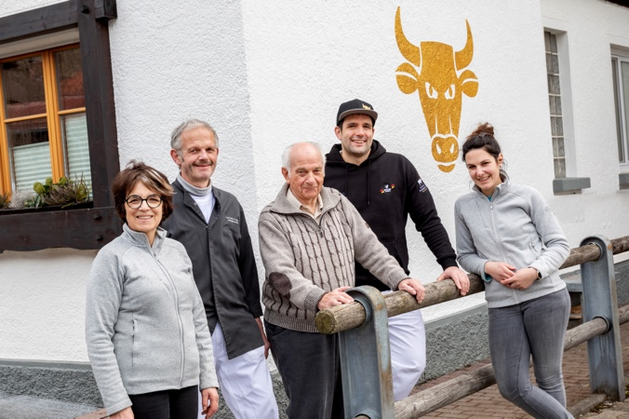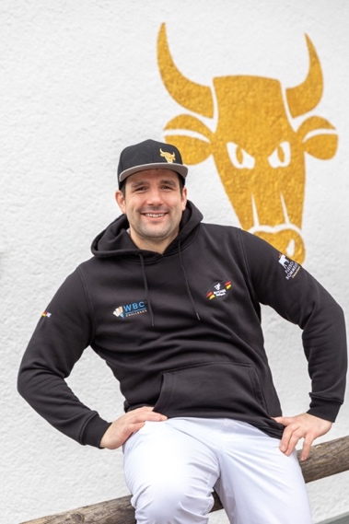
Photos: K+G Wetter (IMG_7048 and IMG_7017)
World Champion butcher Matthias Endraß, pictured here with his parents (left) and grandfather (centre) runs the family business Metzgerei Endraß in Bad Hindelang, Bavaria, together with his sister Ina (right), now in the fourth generation.

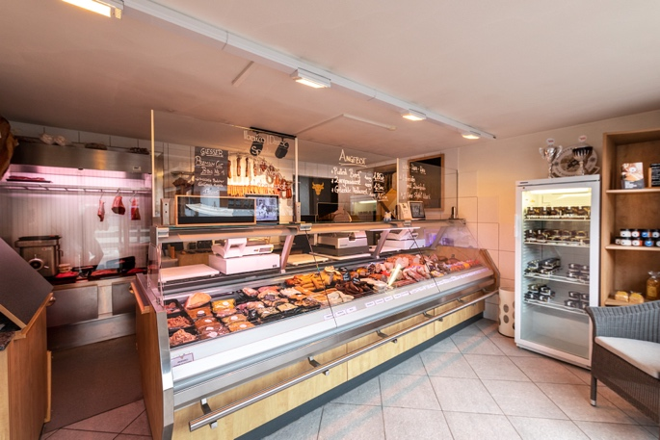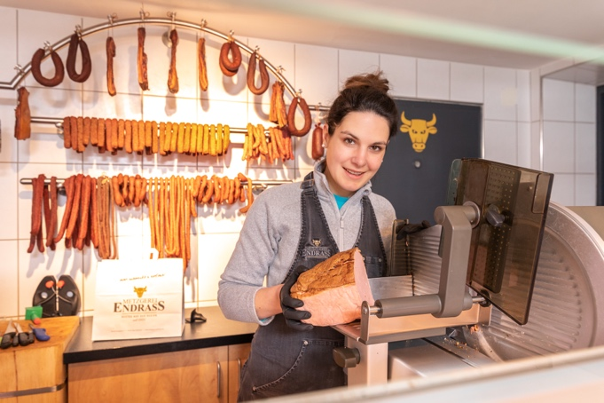
Photo: K+G Wetter (IMG_6846 and IMG_6993)
Ina Endraß-Lacher sells the meat specialities in the Endraß butcher’s shop – for example meat loaf, raw sausage or the latest steak cuts. The specialist saleswoman was the best woman in the competition for young butchers at the World Butchers’ Challenge in Sacramento.

