PRESS INFORMATION
K+G Wetter GmbH
April 2022
One to do it all – Steinemann relies on the new VCM 550 "Hygienic Secure" from K+G Wetter
Industrial bowl cutters produce sausage specialities in over 30 varieties
Steinemann Holding GmbH & Co. KG has 30 varieties of sausage specialities on offer – and relies on one machine to produce the sausage meat: the VCM 550 from K+G Wetter. The vacuum cooking cutter from 2011 was joined by its younger counterpart at the end of 2021, so that two generations of machines are now in service at the family-run meat product manufacturer in Steinfeld in the Oldenburg Münsterland region.
Klaus Haskamp expertly grasps the 200-litre meat trolley and, with a little pressure, securely engages it in the gripper of the hydraulic loading system. With a step to the right, he access the touch panel to trigger the loading process and the meat slides into the 550-litre cutter bowl after a few seconds. The second portion of meat is also quickly added to the bowl cutter, thanks to hydraulics and the quick change of meat trolleys using a foot lever that releases the lock. The stainless steel lid of the new VCM 550 now also closes hydraulically. The recipe with all the ingredients and work steps for the fine liver sausage now being prepared at Steinemann is stored in the CutControl program. "CutControl is designed to cut under program control," explains Steinemann Production Manager Patrick Stephan. "The employee at the machine no longer has to enter each step individually; instead, a recipe is created once with all the work steps along with the exact ingredients and quantities. We still need the employee at the machine, but the knife speed is always the same, the temperature is the same, and vacuum is drawn at the same time and so on. This produces even better consistent and repeatable high quality." The vacuum cooking cutter from 2011 at Steinemann was also retrofitted and optimised with the program developed at K+G Wetter.
When the VCM 550 starts the bowl cutter process under program control, the noise level in the production hall increases – but it is nowhere near as loud as other bowl cutter models of the same size. One reason: the machine stand made of cast iron, which K+G Wetter is the only manufacturer worldwide to use. "The demonstration already showed us how smoothly, cleanly and quietly it runs. Anyone who has ever stood near such a large bowl cutter knows how it rumbles at 3,000 revolutions or more. The great advantage of this cast-iron stand was immediately apparent," says Patrick Stephan.
The fine liver sausage is a cooked sausage, which is why the cooking function of the vacuum cutter is also used in the production hall at Steinemann. "Our new VCM 550 cooks more efficiently because the double-walled bowl heats up very quickly just via the small gap with steam," explains Karsten Camin, Area Sales Manager at K+G Wetter. "Another advantage that is immediately apparent: The exterior of the machine does not get so warm. In other words, we use less energy for the machine and the product while maintaining the same target temperature. As a result, we can cook much faster. And we can cook much faster because we apply the steam directly where it is needed for heating. The same applies to cooling the bowl with water." The completely closed cooking system also reliably prevents contact between steam and product.
After the first step, the hot liver sausage meat is cooled with ice. While the VCM 550 is completing the first bowl cutter pass as specified, Klaus Haskamp has already prepared this next ingredient. The loading trolley with ice is already automatically raised to the pre-loading position and quickly prepared for emptying when the lid is opened. Once the sausage meat has cooled to the right temperature in the cutter bowl, the last and most important ingredient is added: the finely chopped liver. This is where the smooth hydraulic loading of the VCM 550 from K+G Wetter demonstrates its advantages: Although the loading wagon is well filled with the very liquid liver mass, the hydraulics allow it to flow evenly into the cutter bowl without sloshing or splashing.
In the last step, the bowl cutter now mixes all the ingredients into the typical, fine, meat-coloured liver sausage meat, which exudes an appetising aroma. The product is particularly well thickened and without disruptive air inclusions thanks to the vacuum. Why this is even faster with the new VCM 550 than with the ten-year-old previous model can be seen by looking to the right in the production hall: There is the K+G Wetter bowl cutter from 2011 with its much higher vacuum lid. "The much smaller volume of the new VCM 550 naturally makes it much faster to draw vacuum and vent it again," says Karsten Camin. "On the whole, there are clear advantages in terms of bowl cutter time, while maintaining the same quality of the product. If the VCM from 2011 needs 20 minutes for a batch, we are now at 15 minutes per pass. If we then assume 30 batches per day, that is quite enormous," says Production Manager Patrick Stephan. Meanwhile, Klaus Haskamp is emptying the industrial cutter with the unloader. This has been optimised in the new industrial cutter model and empties the 550-litre bowl of liquid liver sausage meat much more quickly and cleanly. On the other side of the machine, the loading device is ready to tip again above the bowl.
In the next room, Dirk Heil is expertly making sausage meat for bologna sausage in the VCM 550 from 2011. The sausage meat for this boiled sausage does not have to be cooked during the bowl cutting process – the machine could do that too, but it would take longer. The older VCM 550 is therefore mainly used for the boiled sausage varieties, while the new machine produces cooked sausage meats.
The new industrial bowl cutter was also equipped with the energy measurement system developed by K+G. It allows the power consumption of each individual batch to be determined with batch accuracy. As a result, the exact costs can be included in the product calculation. It also helps to avoid energy peaks during production.
The meat for Steinemann's over 30 specialities comes from the agricultural region surrounding the company: "Well over 90 per cent of our livestock comes from within a 100-kilometre radius," explains Managing Director Andreas Steinemann, who runs the owner-managed medium-sized company together with his cousin Aron Steinemann and Carsten Knief. "It is still the goal to reach 100 per cent within 100 kilometres. The animals come from contract farmers and producer groups." The K+G Wetter industrial cutters for the production of sausage meat for the more than 30 sausage specialities have also convinced Andreas Steinemann: "Of course we make food in large batches, but we make it to workmanship standards with good raw materials. In the end, that is what quality is all about. The head of the company in third generation cites the suckling pig liver sausage in natural casing as an example. "It has a content of added bacon. Since we also produce cured products, it was our idea to combine the two. I haven't seen that anywhere else." The Steinemann products, currently about 3,000 tonnes of sausage, 3,000 tonnes of cured products and 12,000 tonnes of self-service meat per year, are distributed mainly in food retail, by the way, under the name of customers or with their own Steinemann label. The medium-sized company currently employs around 800 people.
Meanwhile, the working day is drawing to a close in the production hall with the two vacuum industrial cutters from K+G Wetter, and the machines now need to be cleaned. The new VCM 550 once again takes advantage of ten years of further innovation and improvement. As part of the Hygienic Secure series, the machine is clearly focussed on perfect cleaning in terms of product safety. "As a company, taking responsibility for the entire product is even more important today and is also appreciated by customers. This also involves supporting our employees, also from a technical point of view," says Andreas Steinemann. "I find it very exciting that you can now see such technical progress in the same bowl cutter model. When investing and making a replacement purchase, I'm in favour of saying that if you can pick up a technical gimmick or two along the way at the same time, it's twice the fun." Among the innovations that make perfect hygiene quicker and easier are two large cleaning flaps from the 2021 VCM 550 "Hygienic Secure", which allows easy access to the kettle chamber under the cutter bowl and, above all, makes it easy to visually check for cleanliness - which saves water and time. The patented knife cover strip can be unclipped and reinserted for cleaning in one easy step, as can the bowl support pad or scraper. Together with the knife head and knives, Klaus Haskamp places the high-quality bowl cutter components in the special cleaning trolley – here they are safely stored, easy to clean and can dry without forming puddles. Incidentally, the area between the cutter bowl and the vacuum chamber of the VCM 550 does not need a seal, which allows it to be cleaned easily and without leaving any residue.
"The hygiene features naturally also played a decisive role in our decision for the bowl cutter from K+G Wetter," says Patrick Stephan. "Cleaning the inside of a machine is always a big issue. Wherever there is a cavity, something can creep in through some crack and then settle. With Hygienic Secure, the bowl of the new VCM is completely accessible from below and from the side. And many parts of the bowl cutter can be dismantled without needing tools for efficient cleaning. It's not just about saving time, but also about how clean the machine really gets."
After cleaning, both machines and the production hall are sparkling clean and ready for the next working day. And what if something doesn't work? The K+G Wetter team could be connected via the Internet for remote diagnosis. However, Steinemann does not use this at the moment, because the company has its own workshop with experienced specialists. "Of course, support and service is still an elementary issue and decisive for the purchase," emphasises Andreas Steinemann. "When the machines stop, we are unable to supply. That should not happen at all. In the case of K + G Wetter, we also chose the bowl cutter because the issue of support and service simply fits and is handled in a spirit of partnership."
Photos: K+G Wetter
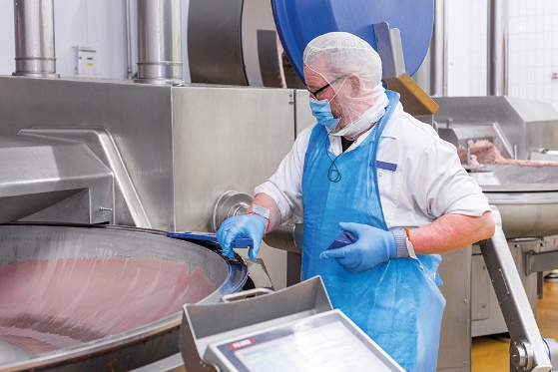
_MGL9472.jpg: Many components of the Hygienic Secure bowl cutter from K+G Wetter can be removed for cleaning and reinserted in no time – for fast and perfect hygiene

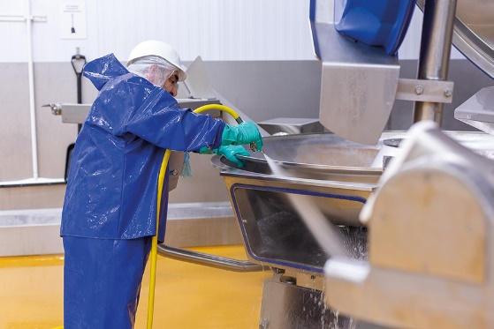
_MGL9624.jpg: No seal is needed between the cutter bowl and the vacuum kettle - the area is particularly easy to clean. The large cleaning flaps of the Hygienic Secure bowl cutters from K+G Wetter facilitate perfect hygiene and thus save time, water and energy.

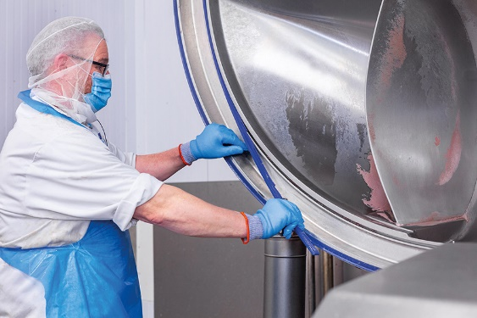
_MGL9455.jpg: Klaus Haskamp removes the knife cover strip and the sealing groove can be cleaned without leaving any residue.
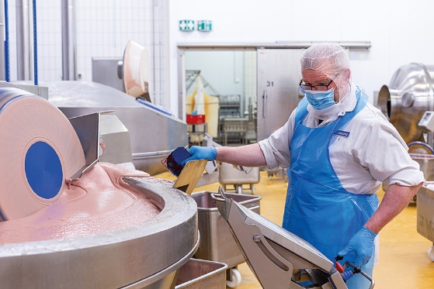
_MGL9391.jpg: The unloader on the new VCM 550 is aligned for particularly fast and clean emptying of the cutter bowl, even with very liquid sausage meat.

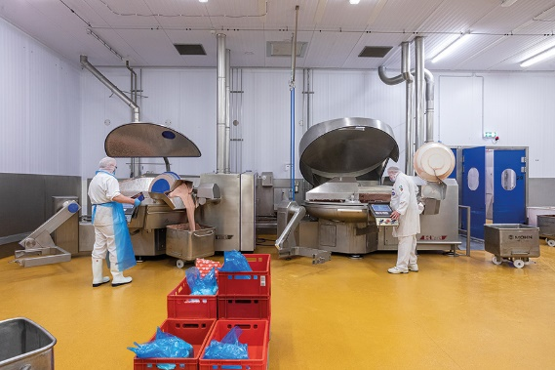
IMG_0063.jpg: The much smaller volume of the new VCM 550 "Hygienic Secure" (left) allows vacuum to be drawn and vented more quickly.

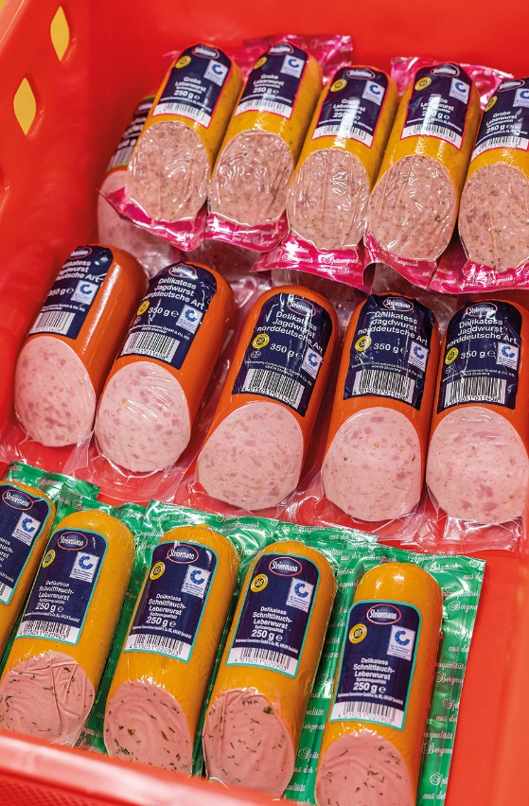
IMG_0181.jpg: Three of Steinemann's over 30 sausage specialities are ready for sale in the food retail trade.

