PRESS RELEASE
K+G WETTER GmbH
July, 2019

Certified hygiene for safe processes
K+G Wetter combines high-tech with top hygienic performance

With their advanced bowl cutters, grinders and mixer angle grinders, the specialists at K+G Wetter have not only incorporated progress into their creations, but also their solutions for hygiene. With the "Hygiene tested" by DGUV Test award, the German Food and Packaging Testing and Certification Body confirms the safe effectiveness of this well thought-out technology.
In practical use, for example, the Angle Grinder and Mixer Angle Grinder E 130 / G 160 with "Easy Access" offers a convenient opening for access to the grinder hopper. This not only makes work easier, but also, and above all, makes cleaning easier, thus providing a plus in terms of hygiene. In addition, there is the sorting device, where the manual and the pneumatic device can be completely installed or removed in a few seconds. This enables users to clean the individual components thoroughly and with great ease.
In addition, K+G Wetter's grinders and mixer grinders are equipped with cleaning chambers behind each mixing shaft, feeder and a meat worm intake. These ensure that when, for whatever reason, a seal is no longer fully functional, liquids or smaller product components cannot get into the machine body. They are then safely taken into the chambers. These are rinsed during daily cleaning, which only takes a few seconds, and any impurities are removed.
In this way, such incidences first being detected once an odour has developed, by which time it is usually already too late, is avoided. With the K+G Wetter machines there is sufficient time to inspect the seals and replace them if necessary.

Hygiene is also a top priority with the 120 litre vacuum bowl cutter (VCM 120). The completely enclosed system ensures product safety, for example. Thanks to the special double wall solution of the cutter bowl, no water or steam reaches the sausage meat. Cleaning is also easy to carry out. With the circumferential distance between bowl and vacuum vessel, there are no more seals and there is no chance for product to be deposited
Another advantage for hygiene: All K+G Wetter machines are hand-polished. Thus the roughness of the surface is extremely minimised. This means that adhesions have less chance of becoming stuck. "For us, such hygiene certification is a matter of course. At the same time, of course, we are delighted that our machine solutions have significantly improved hygiene in meat processing," concludes Andreas Wetter, Managing Director at K+G Wetter.

Words: 413
Characters including spaces: 2,553

K+G WETTER GmbH
K+G Wetter is a global partner of choice when it comes to manufacturing high-quality, reliable meat-processing machinery. K+G Wetter develops innovative bowl cutters, meat grinders and mixers for butchers and skilled operators engaged in the meat-processing trade. The sophisticated technology and high-quality processing features of K+G Wetter machines play a significant role in bringing about customers’ corporate success. An internationally renowned brand, this company from Biedenkopf-Breidenstein in Hesse (Germany) supports its customers by dispensing personalised and individual advice.
www.kgwetter.de

Press image 1:
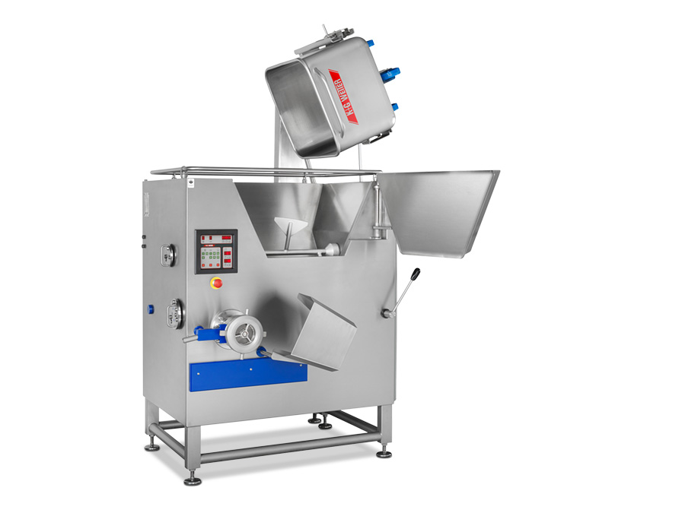
© K+G Wetter
Picture caption: For easy and ideal cleaning, "Easy Access" provides quick and convenient access to the grinder hopper.

Press image 2:
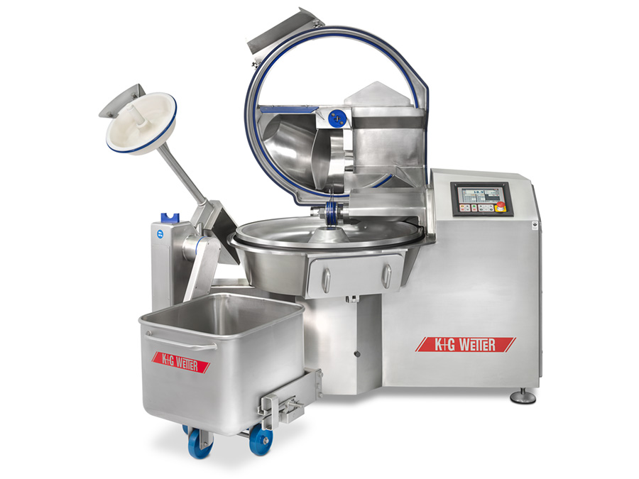
© K+G Wetter
Picture caption: Naturally hygiene certified – the VCM 120 from K+G Wetter with its completely enclosed system and optimum cleaning options.

Contact details:
K+G WETTER GmbH
Goldbergstrasse 21
35216 Biedenkopf-Breidenstein
www.kgwetter.de

Your personal contact:
Stefan Köhler
PR/Media
s.koehler@psv-marketing.de

