PRESS RELEASE
K+G WETTER GmbH
February 6, 2019

Next trade fair: IFFA 2019 Hall 8, Stand D 96

IFFA 2019

K+G Wetter sets new hygiene standards

The family business from Hesse scores highly with clever solutions for industry and trade

This year's IFFA is approaching and, with it, the excitement of what's new to discover in the meat industry. The anticipation is also growing at K+G Wetter. In Frankfurt this year, the Hessians will present machine solutions that not only excel with their top performance, but also with their famous fine details – and bring more efficiency to industry and trade. K+G Wetter is offering a special highlight for industrial companies too. "IFFA is one of the most important international trade fairs for the meat industry and we are delighted to be back again. This year we have developed a highlight for all meat processors in the industry which we will be presenting for the first time at the trade fair and which sets new standards in terms of hygiene", reveals Managing Director Andreas Wetter. K+G Wetter will also be presenting clever solutions for trade businesses in its package at the trade fair.

Cooking system for more efficiency

One innovation at the K+G Wetter booth is the cooking system. Stronger than ever, it now boasts the new 120-litre vacuum bowl cutter (VCM 120), which will also be presented at IFFA, as an advantageous extra. The special features of this further developed solution: The sausage meat can now be heated faster than ever before. K+G Wetter has succeeded in accelerating this process by 30 percent – which of course has a direct effect on the cost-effectiveness of the process. Steam consumption is also reduced by 30 percent thanks to a special double-wall solution in the cutter bowl. With the completely enclosed system, K+G Wetter has implemented a solution that is also unrivalled in terms of hygiene.

Hygienic down to the smallest detail

K+G Wetter is also constantly working on solutions in the field of grinders that will make meat processing in trade and industry more efficient. The innovative "Easy Access" on the newly developed angle grinders and mixer angle grinders E 130/G 160, for example, has more than proven itself in practical use. The generous opening allows direct access to the grinder hopper. This makes it much easier to add spices or other ingredients. The mixing shaft as well as the feeder worm can be installed and removed quickly – which is exactly the same for cleaning. For maximum hygiene and efficiency, K+G Wetter has also further optimised the manual and pneumatic sorting device on its grinders and mixer grinders. It discharges hard parts laterally and can be installed and removed within seconds. The connection of the drive to the locking mechanism of the new sorting system can be easily separated without tools via a plug-in connection. This allows the user to clean the individual components particularly easily and thoroughly.

The automatic grinder AW K 280 has the optimised sorting device too and scores highly with further specific features that make the work much easier. Designed for industrial plants with special requirements, the automatic grinder can process both fresh meat and frozen meat blocks quickly and efficiently. As a new feature, the machine is equipped with an optimised feeder worm counter bearing, which is now attached to the machine body with hinges. Instead of removing the counter bearing, it can be opened easily without tools. For cleaning, the feeder worm is pulled forward only a few centimetres. An internally installed cleaning nozzle automatically cleans the worm intake.

Strong grinding service directly from the professionals

In addition, K+G Wetter also supports its partners from the butcher's trade and the food processing industry with a strong service. Because machines in meat processing usually run at full speed, the sharpness of the bowl cutter knives and grinder cutting sets must be one hundred percent reliable. This is the only way to ensure they work efficiently and cleanly. This is why K+G Wetter offers its partners a solid and fast all-round service for the professional regrinding of bowl cutter knives and grinder cutting sets. If the performance of the knives or cutting sets decreases, the K+G experts will provide the correct sharpening again within the shortest possible time and return the tool immediately. For quality that you can taste in the end.

Further information on the machines, services and innovations from K+G Wetter can be found at IFFA, Hall 8, Stand D 96 or at www.kgwetter.de.

Words: 730
Characters including spaces: 4.462

K+G WETTER GmbH
K+G Wetter is a global partner of choice when it comes to manufacturing high-quality, reliable meat-processing machinery. K+G Wetter develops innovative bowl cutters, meat grinders and mixers for butchers and skilled operators engaged in the meat-processing trade. The sophisticated technology and high-quality processing features of K+G Wetter machines play a significant role in bringing about customers’ corporate success. An internationally renowned brand, this company from Biedenkopf-Breidenstein in Hesse (Germany) supports its customers by dispensing personalised and individual advice.
www.kgwetter.de

Press photo 1:

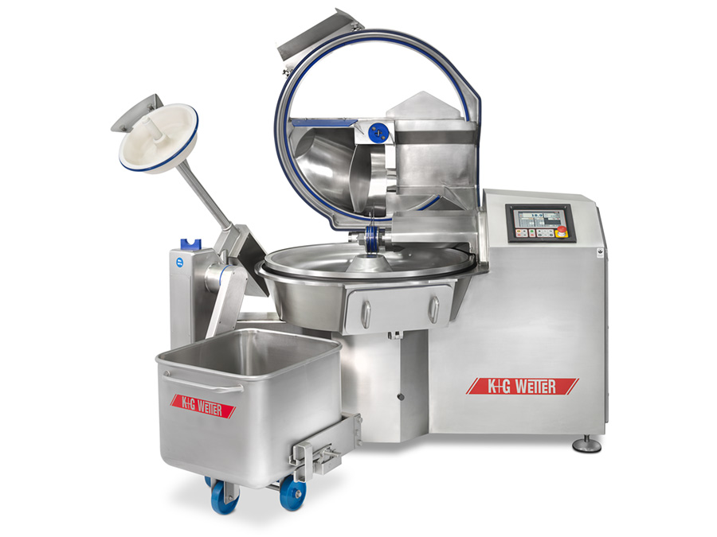

© K+G Wetter

Photo caption: With the new cooking system, which is optionally available exclusively for the VCM 120, K+G Wetter has realised a solution that is also unrivalled in terms of hygiene.

Press photo 2:

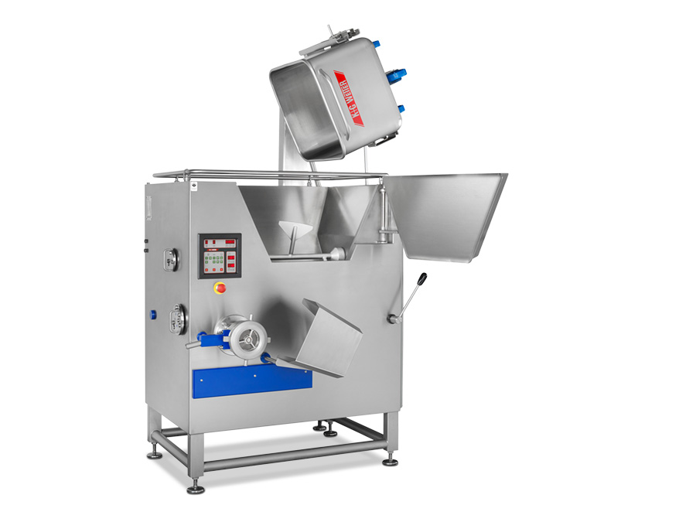

© K+G Wetter

Photo caption: In practical use, the innovative "Easy Access" has more than proven itself on the newly developed angle grinders and mixer angle grinders E 130/G 160, which allow direct access to the grinder hopper.

Press photo 3:

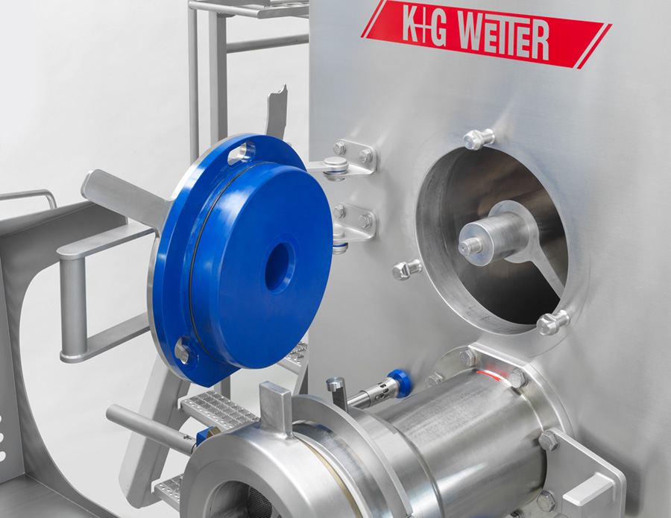

© K+G Wetter

Photo caption: Clever in the details: The new feeder worm counter bearing can be opened easily and without tools.

Contact details:
K+G WETTER GmbH
Goldbergstrasse 21
35216 Biedenkopf-Breidenstein
www.kgwetter.de

Your personal contact:
Stefan Köhler
PR/Media
s.koehler@psv-marketing.de

