Culinary excursion to the weekly Mediterranean market
The Oliven + Öl Compagnie produces Mediterranean specialities using bowl cutters from K+G Wetter

Entering Oliven + Öl Compagnie’s shop evokes a feeling of being a few hundred kilometres further south. Instead of being in the “Casa Verde” in Benningen in the Allgäu region of Germany, looking out over the Alps, you suddenly find yourself transported to a weekly market in Tuscany, Mallorca or Crete. An intense garlic fragrance pervades the air along with the resinous aroma of rosemary, fresh thyme, pepper and spices. This feeling intensifies as you take a closer look at the food on display: Amidst shelves of wine, sweet specialities and pasta, several dozen varieties of olive preparations, tapas, creams, dips and antipasti dominate the long refrigerated counter and awaken your desire to picnic under the pines. Tomato red, basil green and paprika yellow radiate from the bowls, accompanied by olives in all shades of black and violet and creamy white sheep’s cheese.

The creations of Jörn Niederberger and Martin Mang take all your senses on a spontaneous journey to a Mediterranean village. At the end of the 1980s, the two managers of the Oliven + Öl Compagnie at the time took over the business, producing Mediterranean specialities and creating a holiday-like feeling on their customers’ tables. Initially, they only set up stalls at regional weekly markets, but they have also had a shop and production facility on the outskirts of the Allgäu town of Benningen since 1996.

“The weekly markets allow us to test our customers’ reaction to our fresh products at any time. We offer a taste of everything – and get an immediate response; it couldn’t be better,” explains Jörn Niederberger. Today, you can find the Oliven + Öl Compagnie’s sales vans at about 20 weekly markets within a radius of 130 km. In addition to the “Casa Verde” shop at its production facility in Benningen, the company also supplies delicatessens and butchers who very much value the opportunity to expand their range of delicacies. “Every visitor to Italy returns with a fantastic impression – now, all of these products can be found here in abundance. We cover the entire Mediterranean region”.

Directly behind the “Casa Verde” shop in Benningen are the production halls of the Oliven + Öl Compagnie. Here, Sebastian Laub, one of the 70 or so employees, stands over the CM 70 STL from K+G Wetter, preparing a new batch of fresh cream cheese. The bowl cutter has served the company well for two years, after being purchased on the recommendation of a colleague. “By word of mouth, we learned that he really was very satisfied with his machine,” recalls Jörn Niederberger. “We then spoke by phone and, very spontaneously, decided that it would suit us too.”

Incidentally, the Oliven + Öl Compagnie does not process any meat at all; the sausage and ham sold in the shop and from the market vans are bought in from selected suppliers throughout the Mediterranean. “We don’t even have a meat processing licence,” adds Jörn Niederberger. Nevertheless, the bowl cutter from meat machinery and butchery equipment manufacturer K+G Wetter is perfectly designed for processing Mediterranean ingredients into delicious creams, dips and pastes.

The Cutmix with a bowl volume of 70 litres is fitted with the variable STL drive: This makes the knife shaft and mixing speed infinitely variable. Users can store up to six forward and two reverse knife speeds, making proven and frequently used settings available at the touch of a button. The standard limit switch is also fitted, which allows definable temperatures, bowl revolutions and times to be set.

“The infinitely variable drive is ideal for us, because we don’t just use our bowl cutter for making pastes and creams. We also use it to grate Parmesan cheese, for example, which has quite a hard consistency, and for processing these dried tomatoes into a paste that we also use. We use the machine for all these things,” says Oliven + Öl boss Niederberger. “The major benefit for us is that the K+G Wetter machine doesn’t generate such a great deal of heat as our old machine did. This is of course, a key aspect in terms of product quality.” The result is a homogeneous mass, regardless of the starting product. It means that all of our preparations have the desired consistency. “This is very important to us. For instance, when we receive a delivery of sheep’s cheese – the cubes of which are also a little tougher – everything still gets perfectly mixed.”

The company uses a universal knife in its bowl cutter. The six blades grind a wide variety of different ingredients to the desired fineness – from hard Parmesan cheese to tough dried tomatoes and compacted sheep’s cheese. To ensure that the blades are always perfectly sharp, the Oliven + Öl Compagnie has purchased two sets of knives. “When the knives get blunt, we send them back to K+G Wetter. After two days at the latest, they come back wonderfully sharpened and ready for work. We are often surprised at how quickly our knives are returned,” says Jörn Niederberger about his experience with K+G Wetter’s service.

At the machine, Sebastian Laub fills the cutter bowl with several portions of cream cheese and has the cutter mix the cream base first. Spices and a flaming red, slightly chunky paste of dried tomatoes are then added to the white mass. The Compagnie worker also prepared these beforehand in the CM 70. Together with olive oil, a bowl of bright green herbs and, of course, a good portion of fresh garlic, the bowl cutter quickly transforms the ingredients into a fragrant cream, with an appetisingly bright red colour and evenly dotted with fresh green pieces. Although the full volume of the cutter bowl is utilised, none of the high-quality end product spills over – this is ensured by the raised rim of the cutter bowl – a feature of all K+G Wetter bowl cutters.

Oliven + Öl Compagnie workers are just as satisfied with their bowl cutter as are customers at the shop and weekly markets with the specialities the machine produces. “It’s not really much help when the boss lets his imagination run wild, but the kitchen staff think, ‘that may be great for you, but I have to operate this thing every day’,” smiles Jörn Niederberger. “With the bowl cutter however, handling and cleaning are really easy for the staff; they are thrilled. I would thoroughly recommend this machine to anyone.” Another benefit for the staff in the Compagnie’s kitchen is that the machine runs extremely quietly, despite its size and powerful motor – thanks to the cast iron machine base, which is only available from K+G Wetter. Incidentally, one special feature that Compagnie has treated itself to with the new bowl cutter is the electrically operated knife cover. Just tapping on the touch panel causes the cutter’s heavy metal lid to open and close, saving the staff many strenuous, unergonomic movements every day. “Initially, this was more of an afterthought, but this solution has proven itself through and through,” reports Jörn Niederberger.

Although the Oliven + Öl Compagnie wholeheartedly supports the slow food movement, it greatly appreciates time savings offered by the 70-litre bowl cutter – which replaced a much smaller processing machine two years earlier – despite all the manual work to produce artisanal quality. “To make one batch weighing some 50 kilos, we previously required three processing runs, meaning we had to rinse the machine out twice in between, consuming valuable time.”

Keyword cleaning: The CM 70 can also be cleaned thoroughly in the shortest possible time, because K+G Wetter has always placed great importance on hygiene in the design of its machines. In addition to the machine body, which is made of hand-polished stainless steel, clever solutions for sensitive areas enable optimal hygiene. The knife cover strip, which can be removed for cleaning and re-fitted in a single operation, is a good example of this. Since the products of the Oliven + Öl Compagnie do not contain any preservatives, the issue of hygiene is even more important here.

Jörn Niederberger, at any rate, is satisfied – not only with the new batch of cream cheese with its Mediterranean market day aroma and which is now being packaged for sale, but also with his CM 70 STL. “The machine supports our operations and our philosophy of putting quality first. We purchase high-quality raw materials – and now we have an excellent machine to process them, we are turning out some truly outstanding results. The quality is simply spot on, regardless of the product – and our customers are really appreciative.

The Oliven + Öl Compagnie

The Oliven + Öl Compagnie with production, dispatch and the “Casa Verde” shop is based in Benningen in the Allgäu region of Germany. From here, on the border between Baden-Württemberg and Bavaria, the sales vans are also dispatched to weekly markets in the wider region.
“The southern way of life, the passion for authentic food, quality and taste have cast their spell on us. When it comes to our suppliers, we place particular emphasis on having the best raw materials and conscientious processing,” say the two managing directors Jörn Niederberger and Martin Mang, who have been running the Compagnie together with their families since 1987.

www.olivencompagnie.de

www.kgwetter.de

Photos: K+G Wetter
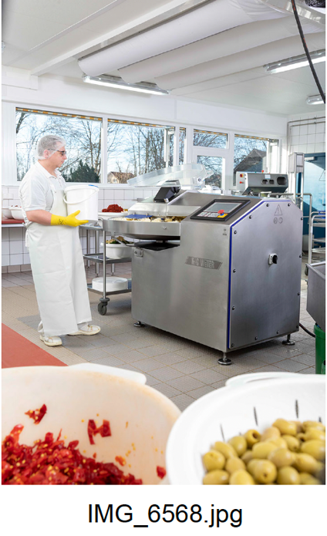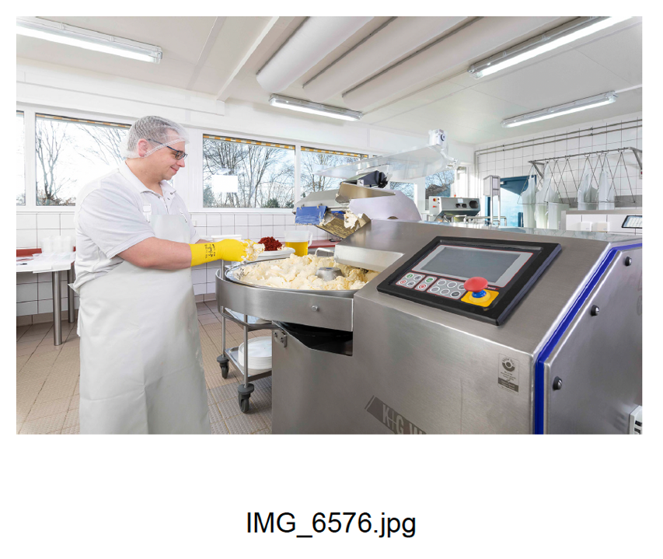

The K+G Wetter CM 70 STL bowl cutter is at the heart of production at the Oliven + Öl Compagnie.

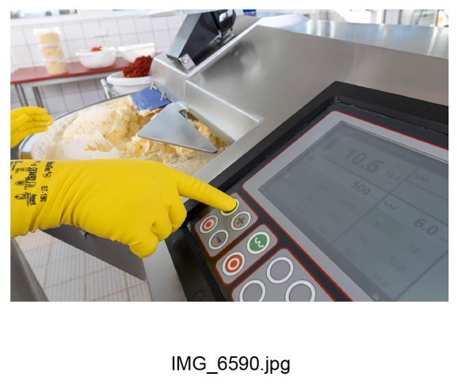
All of the machine’s functions can be controlled via a user-friendly and hygienic touch panel.

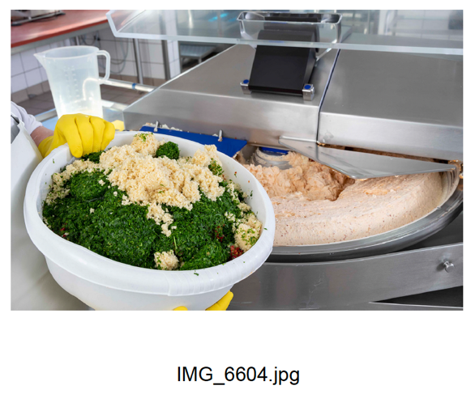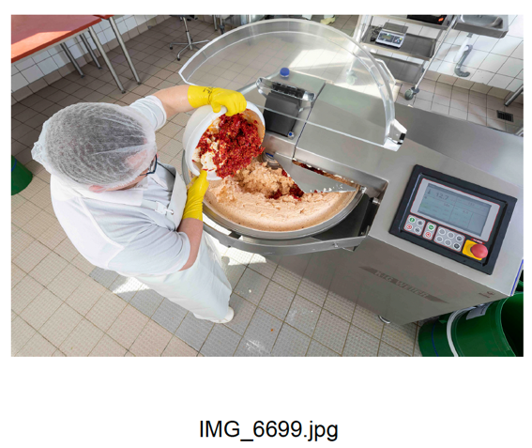
The raised rim of the cutter bowl prevents overflow, meaning the machine stays clean and product loss is prevented.
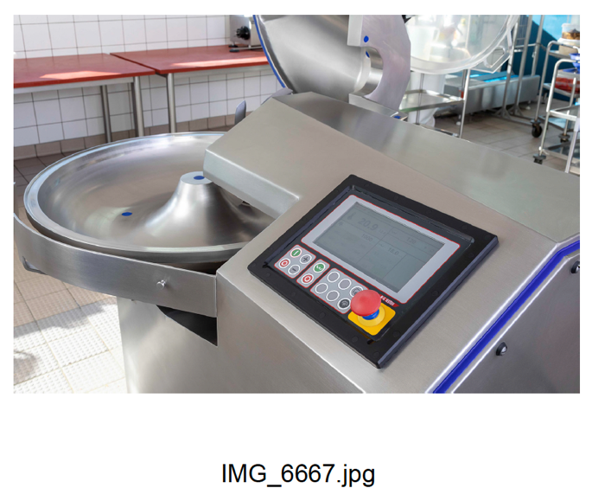
Thanks to the finely polished stainless steel surfaces and hygienic features such as the removable knife cover strip, K+G Wetter bowl cutters are particularly hygienic when it comes to cleaning.

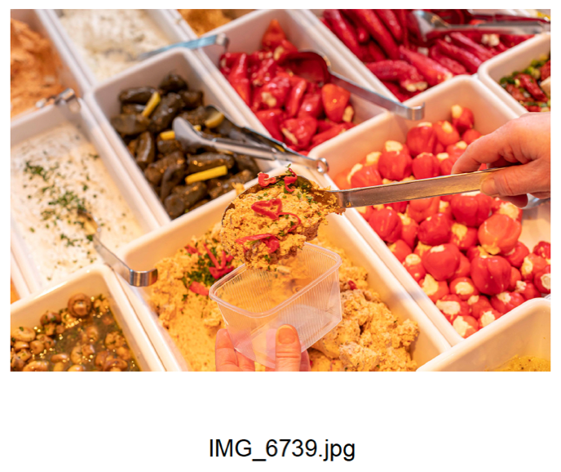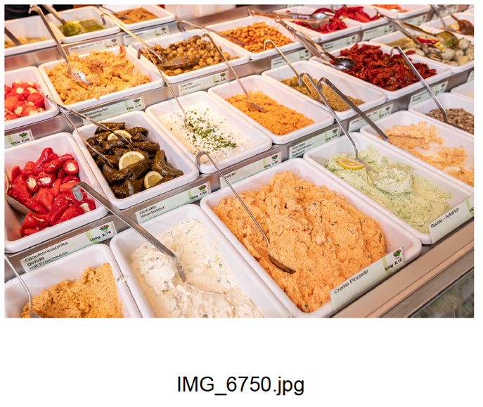
The Oliven + Öl Compagnie’s products, freshly prepared every day, take you on a Mediterranean market stroll with their colours, fragrances and flavours.

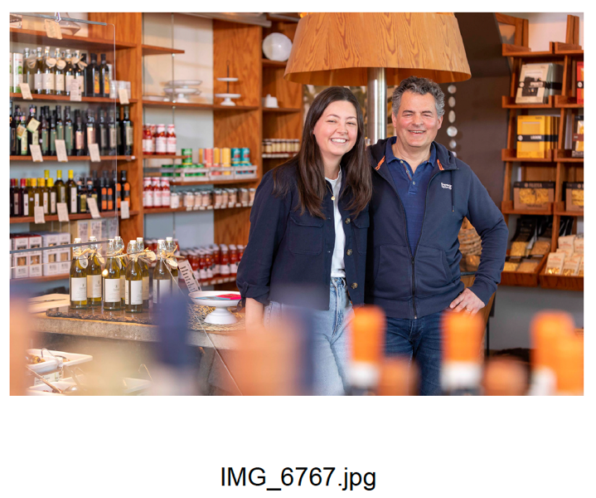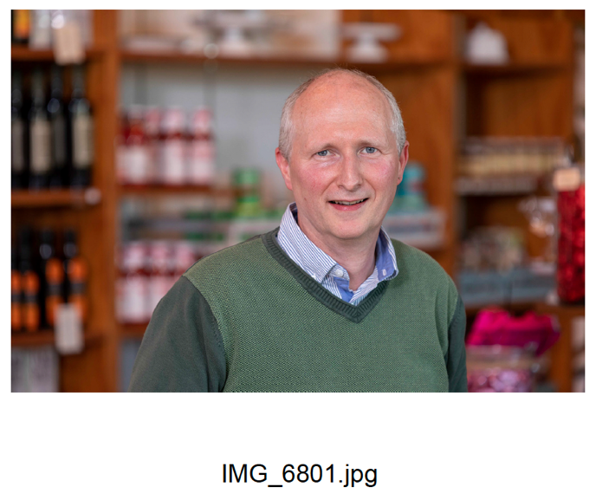
Oliven + Öl Compagnie managing directors Jörn Niederberger (left, with daughter Alina) and Martin Mang (right)

