PRESS RELEASE
K+G Wetter GmbH
March 2021
Optimisation of Warehouse Logistics

Warehouse logistics further optimised
Investment ensures process improvements

News from K+G Wetter: Following expansion of our production areas in 2018 and 2020 and the associated optimisation of operating procedures, investments have now been made in warehouse logistics at our facility in the Breidenstein district of Biedenkopf in the German State of Hesse. By optimising its entire processes, the specialist meat processing machine manufacturer intends to continue strengthening its market position. Especially for a medium-sized enterprise like K+G Wetter, flexibility is an extremely important tool for setting the company apart from the ever-growing number of market players. The redesign of the warehouse logistics combined with the conversion almost doubled the storage capacity for pallet storage spaces and in the shelf storage area. In the process, the small parts warehouse has been expanded to two levels.

All processes, such as incoming and outgoing materials, have therefore been further modified and improved, picking speeds have been increased and process times reduced. Moreover, additional material handling vehicles have been taken into use.

“The optimisation of our warehouse logistics is another key milestone in the history of K+G Wetter. Rapid delivery times for new machines, and also for spare parts, are an important parameter in this highly competitive market. Accordingly, the aim here is to fully exploit potentials and achieve the shortest possible response times in the interest of our customers. Because K+G Wetter is a family-run company and proximity to customers is our top priority. We want to position ourselves for the future in order to offer our customers the best possible all-round service,” explains plant manager Marco Beimborn.

K+G Wetter
K+G Wetter is a global partner of choice when it comes to manufacturing high-quality, reliable meat-processing machinery. K+G Wetter develops advanced cutters, grinders and mixers for butchers and skilled workers in the meat-processing trade and industry. The company's sophisticated technology and high-quality processing mean that machines from K+G Wetter contribute significantly to customers' business success. As a world-famous brand, the company from the Breidenstein district of Biedenkopf, in the German State of Hesse, supports its customers with personal and individual advice.
www.kgwetter.de

Press images 1- 3:
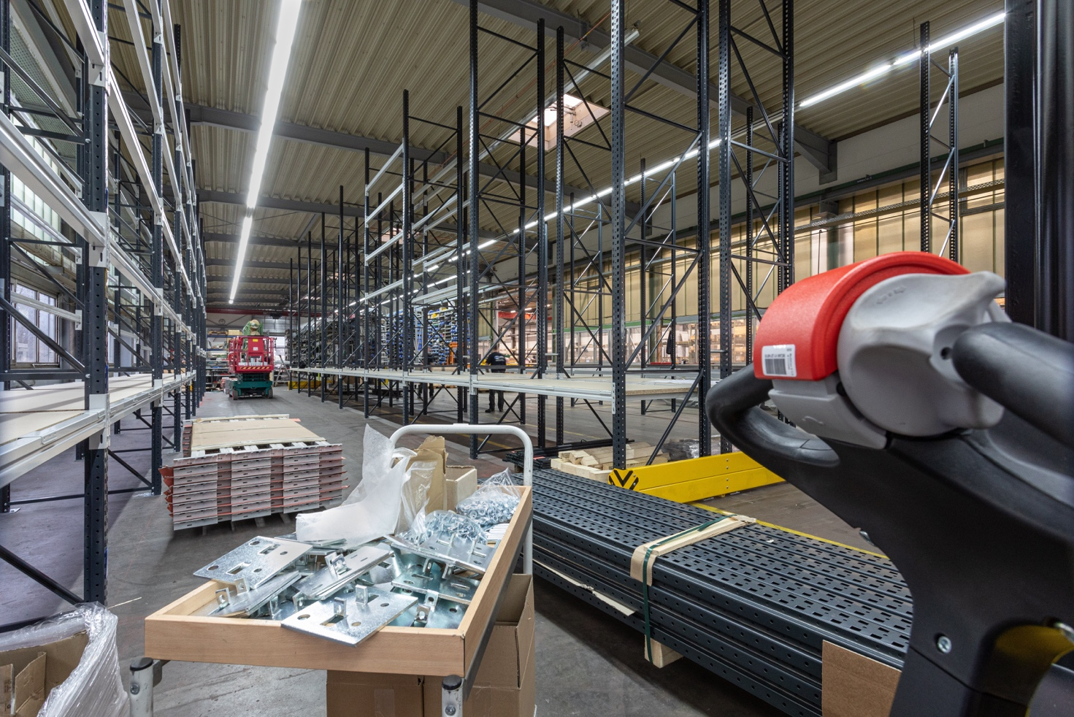

© K+G Wetter

Photo caption: Something’s happening at K+G Wetter: Once again investments are being made at our facility in the Breidenstein district of Biedenkopf to optimise warehouse logistics there. This is another milestone in the history of K+G Wetter and a further step in the company's focus on customer satisfaction.

Press image 2:
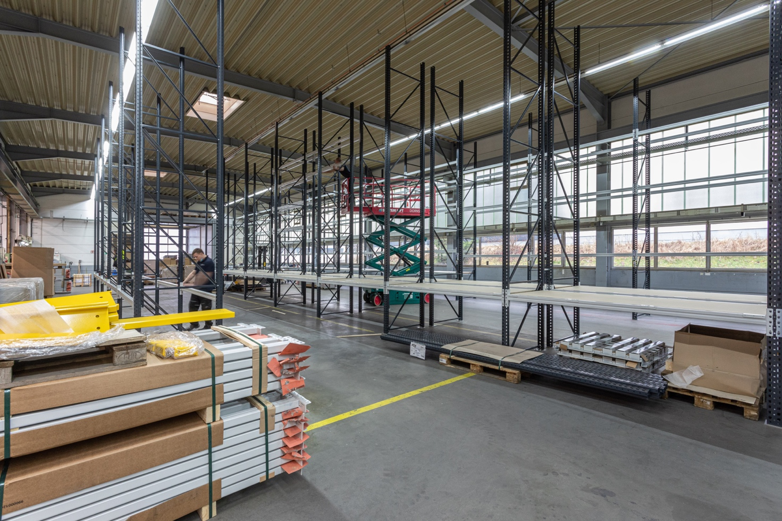
© K+G Wetter

Press image 3:
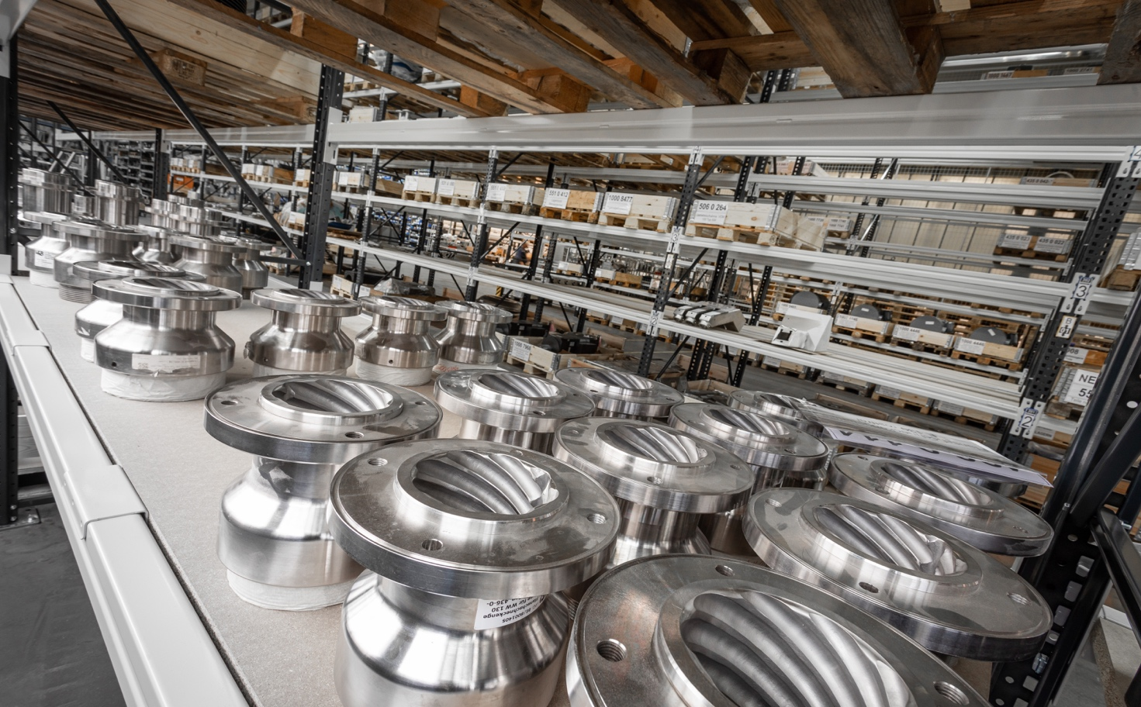
© K+G Wetter

Press image 4:
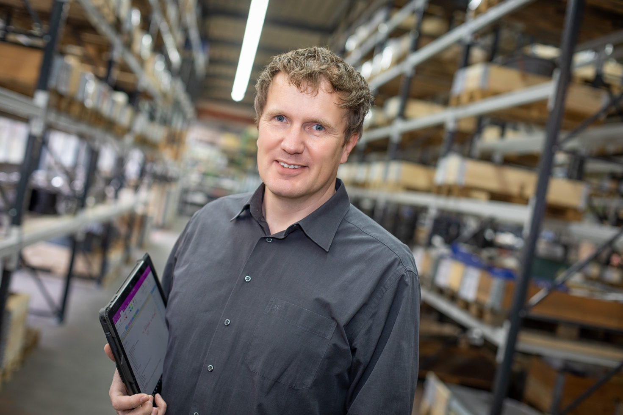
© K+G Wetter

Photo caption: “We are constantly strengthening and underpinning faster response times. This future-proofs our business and allows us to offer our customers the best possible service at all times,” emphasises plant manager Marco Beimborn.

Contact details:
K+G Wetter GmbH
Goldbergstrasse 21
35216 Biedenkopf -Breidenstein
www.kgwetter.de

Your contact partner:

Katharina Hennig
PR/Media
T. +49 (0) 2 71 . 77 00 16 - 160
F. +49 (0) 2 71 . 77 00 16 - 29
k.hennig@psv-neo.de
www.psv-marketing.de

